**Machine Learning Foundation with Cloud [CSE457]**

**LAB FILE**

Submitted to

**AMITY UNIVERSITY UTTAR PARDESH**



In partial fulfilment of the requirements for the award of the degree of

Bachelor of technology in

Computer Science & Engineering

by

**AAKANKSHA KAUSHAL**

**A2305221165**

Submitted to: **Prof. (Dr) Sanjeev Thakur**

DEPARTMENT OF AMITY SCHOOL OF ENGINEERING

AMITY UNIVERSITY UTTAR PARDESH

NOIDA (U.P.)

**LAB – 1**

Objective: Amazon SageMaker - Creating and importing data

Procedure:

1. Accessing the AWS Management Console

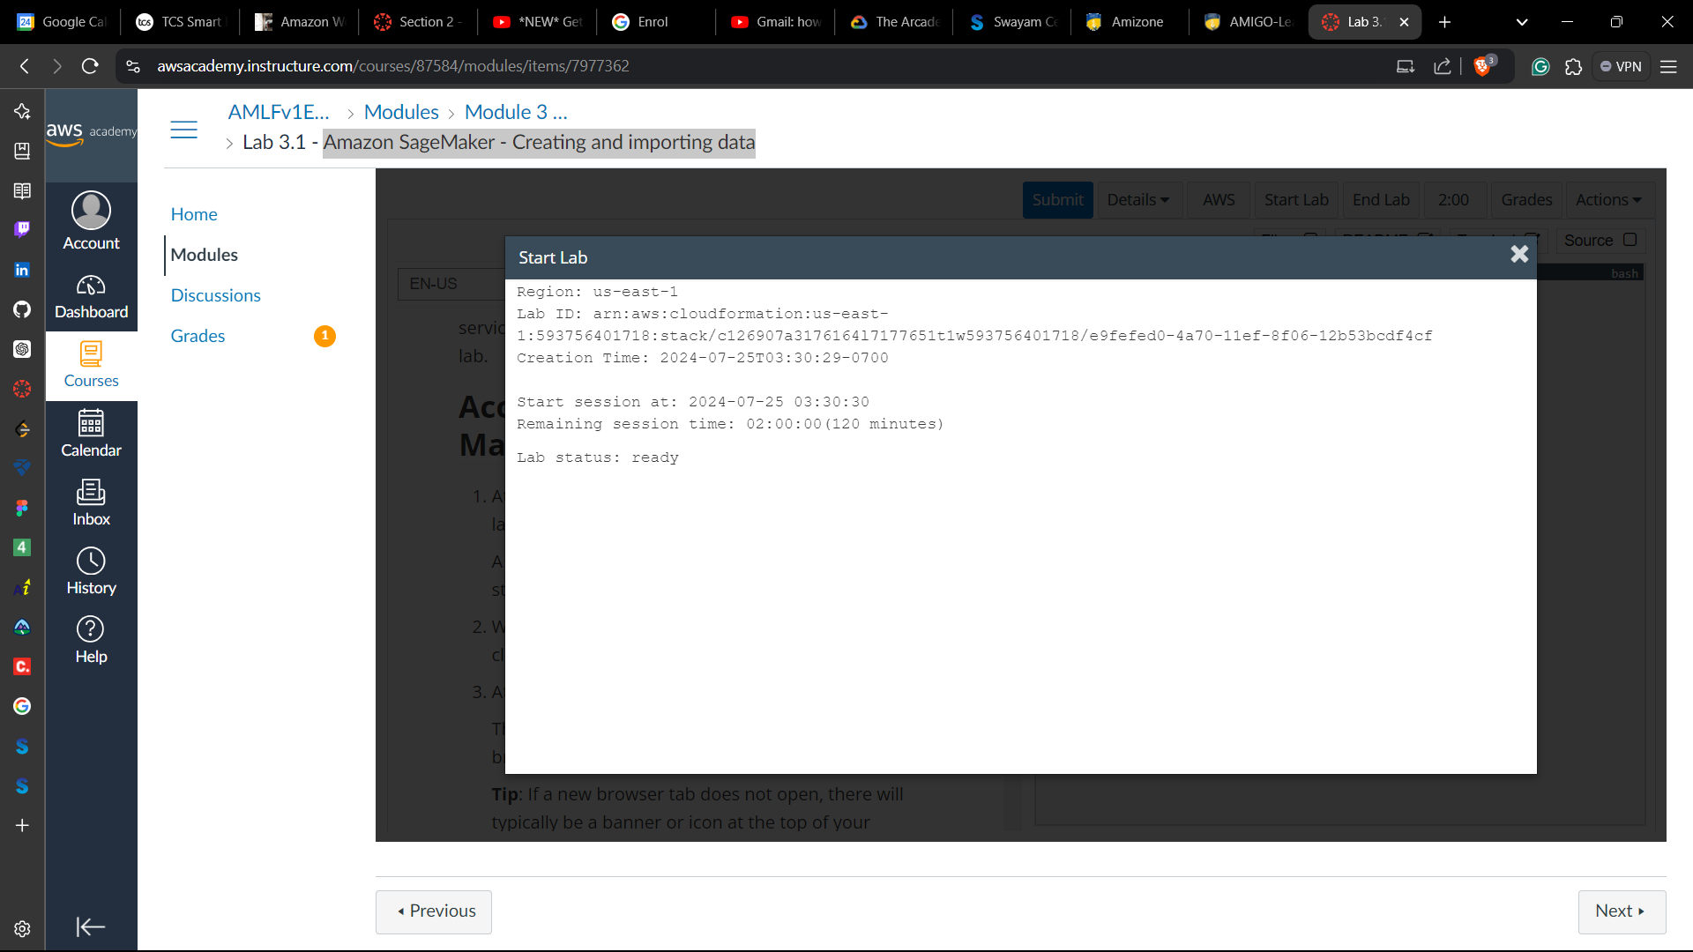

**Task 1: Creating a Jupyter notebook with Amazon SageMaker**

1. Choose **Amazon SageMaker** from the **Services** menu in AWS Management Console
2. From the **Notebook** section and choose **Notebook instances**.
3. Choose **Create notebook instance**.

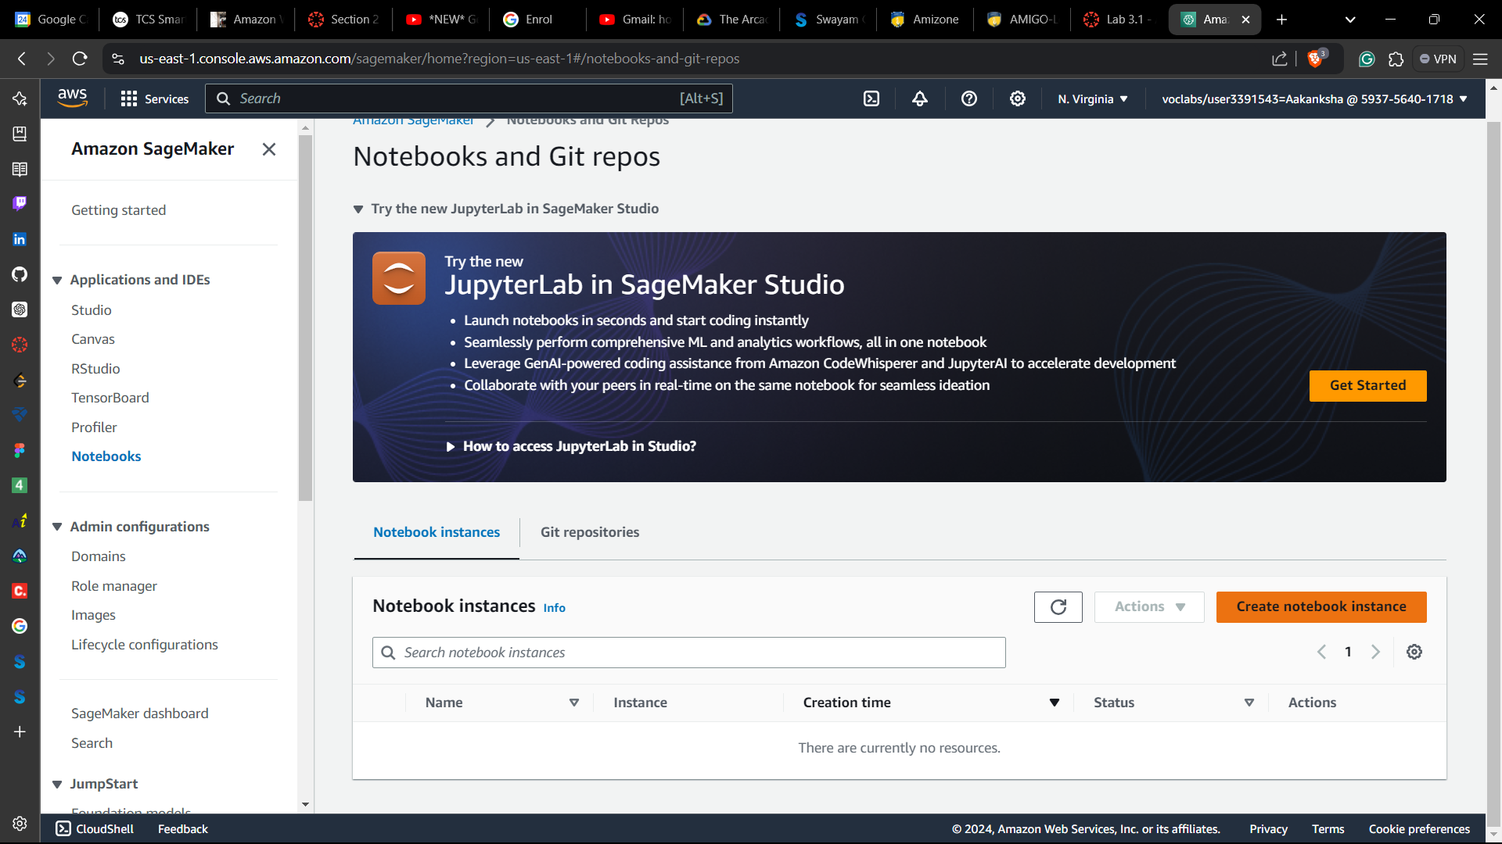

1. In the **Notebook instance name** box, enter Mynotebook and choose **ml.m4.xlarge**.as **Notebook instance type** and set the Platform identifier type to **notebook-al2-v1**,

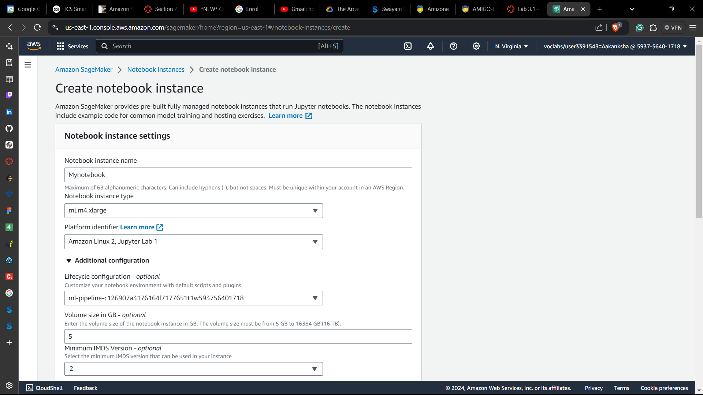

1. Choose **Create notebook instance**.

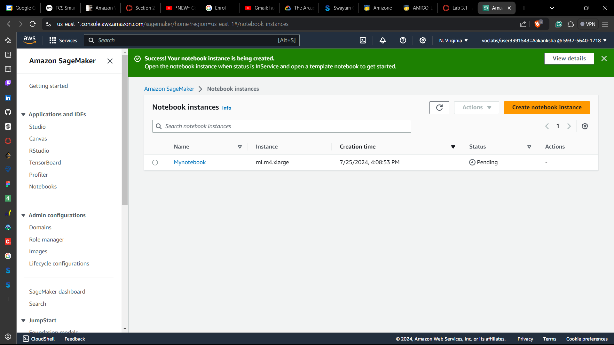

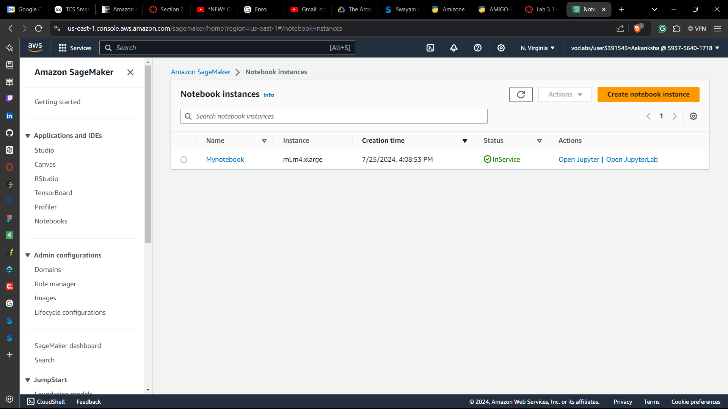

1. At the end of the row, choose **Open JupyterLab** to open the Jupyter notebook instance.

**Task 2: Introducing JupyterLab**

1. In the JupyterLab GUI, open the folder for your desired language, then open the **PythonCheatSheeet.ipynb** notebook file.

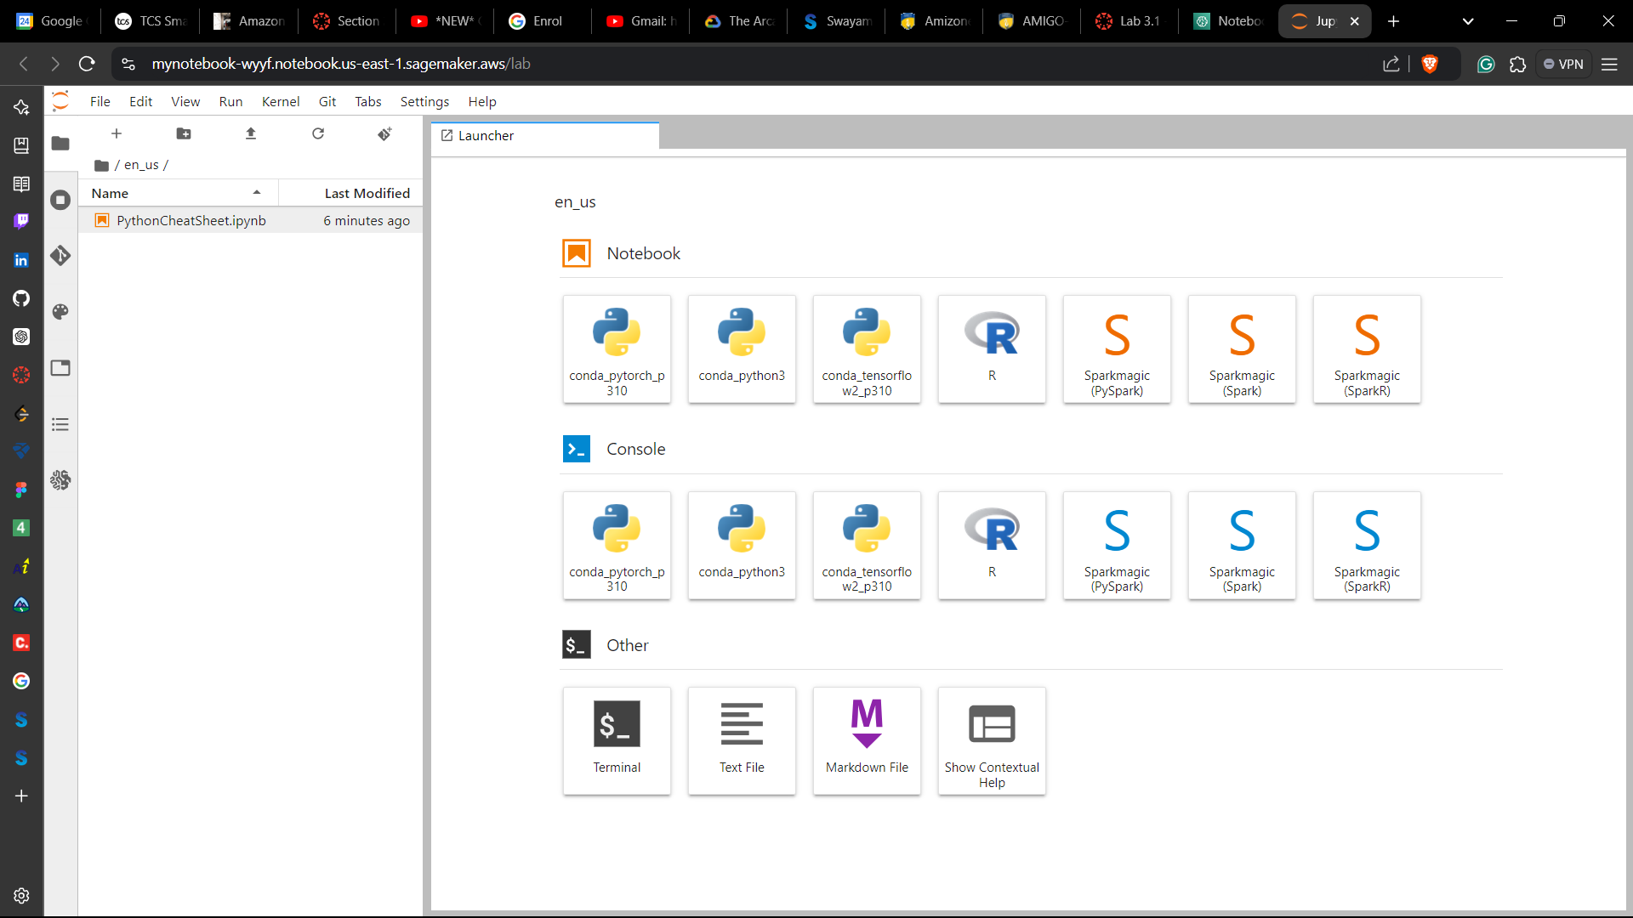

1. Explore through the Cheatsheet and run through the data once

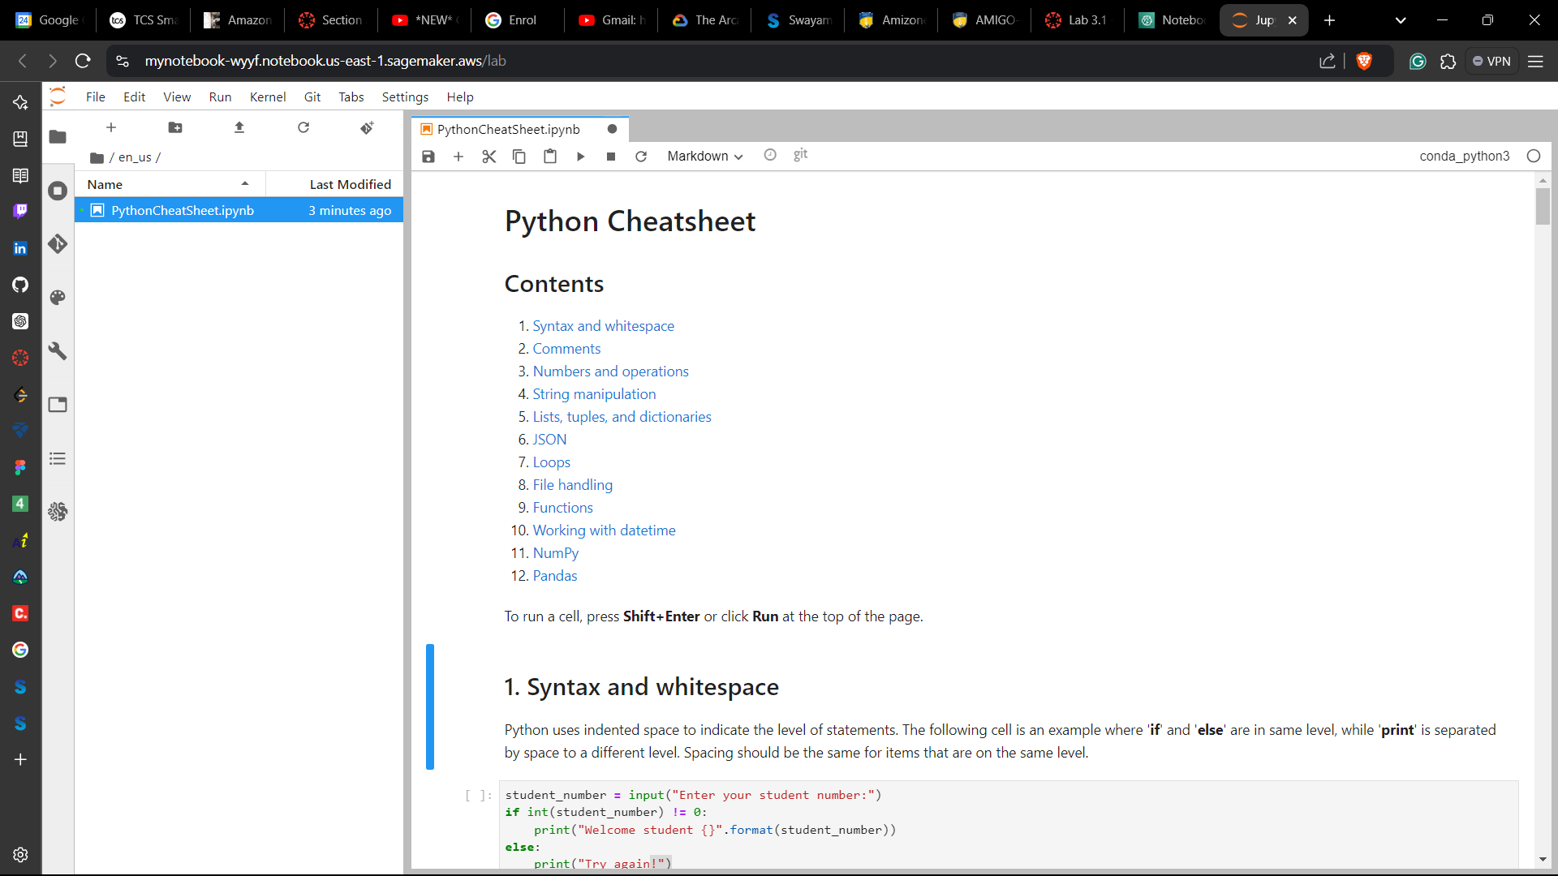

**Task 3: Opening a sample notebook**

1. In your JupyterLab environment, switch the left navigation view to the *Amazon SageMaker Samples*.

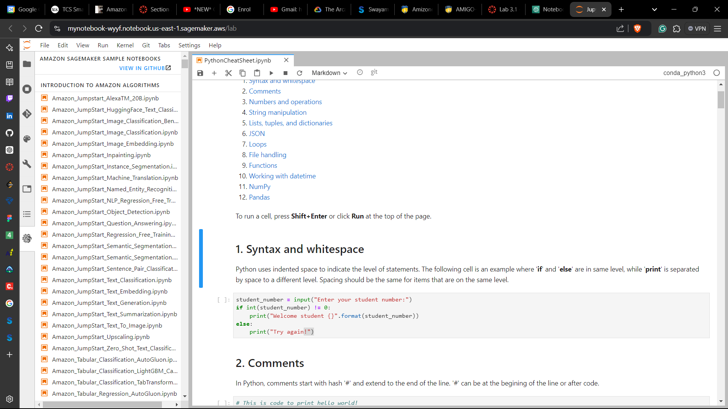

1. Locate the sample named *linear_learner_mnist.ipynb*. and create a copy by choosing the **Create a Copy** button and in the dialog box & **Create a Copy** again.

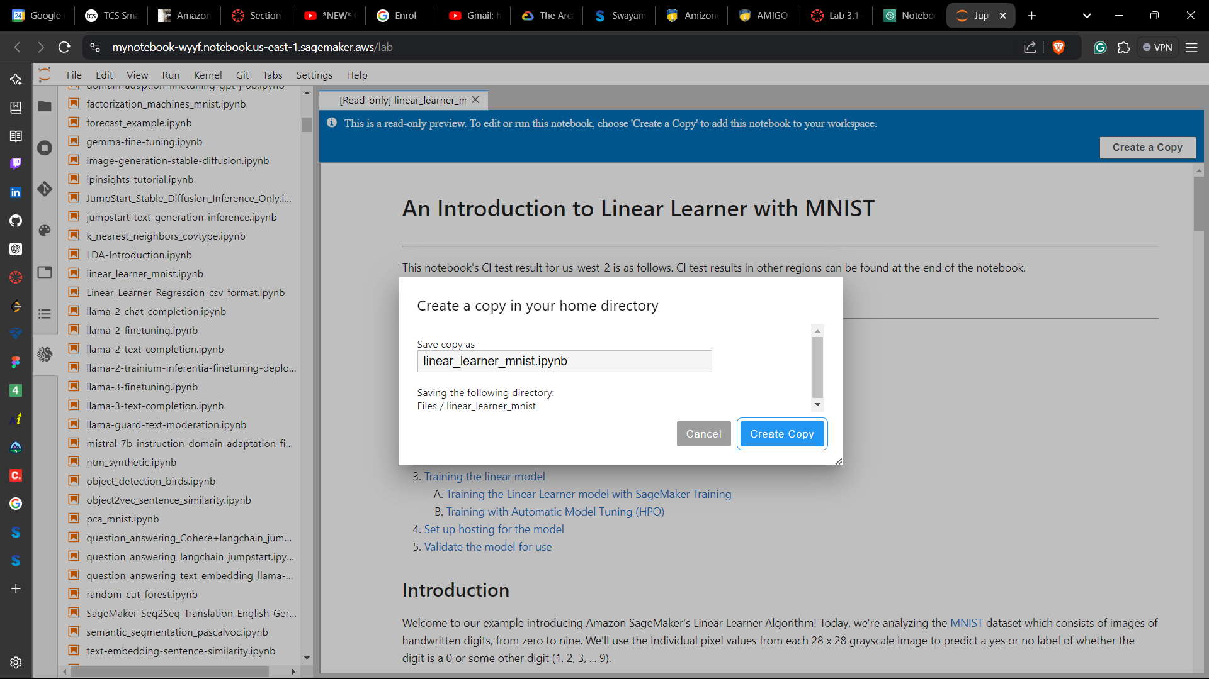 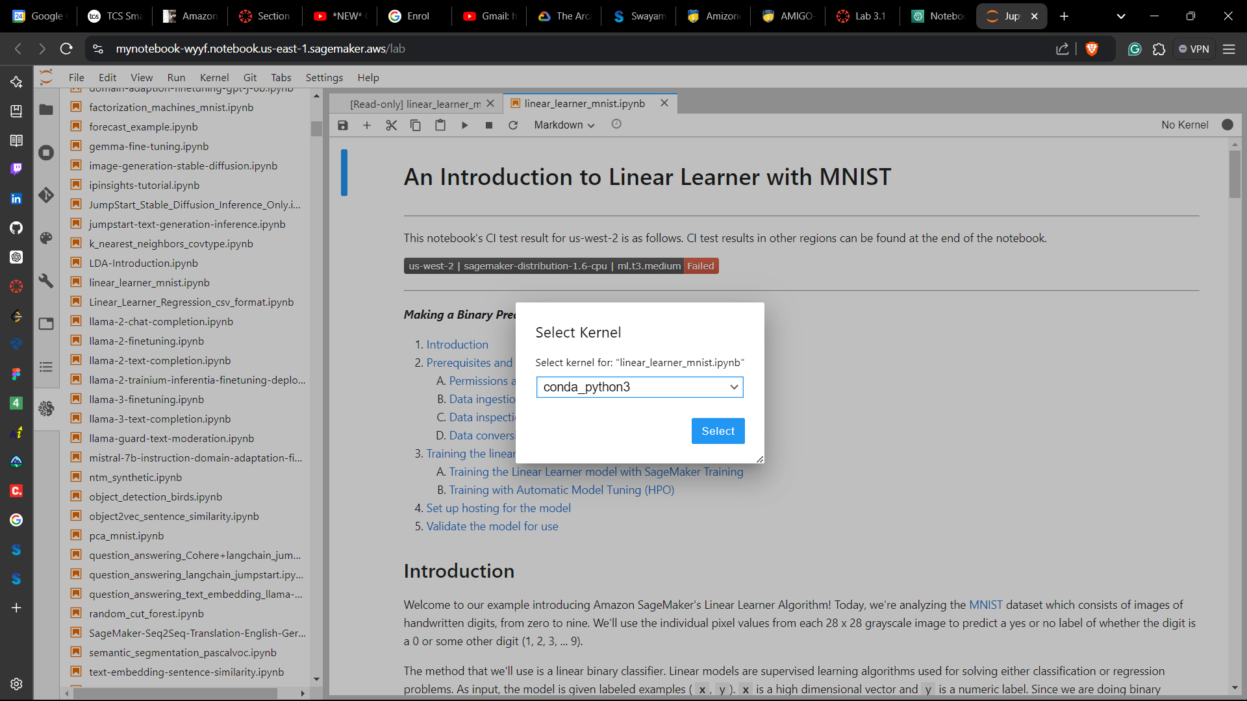

The sample notebook will be copied to your JupyterLab environment.

**Task 4: Importing data**

To obtain, extract, and load the data into a pandas DataFrame:

1. In your JupyterLab environment, choose **File > New** and then choose **Notebook**.

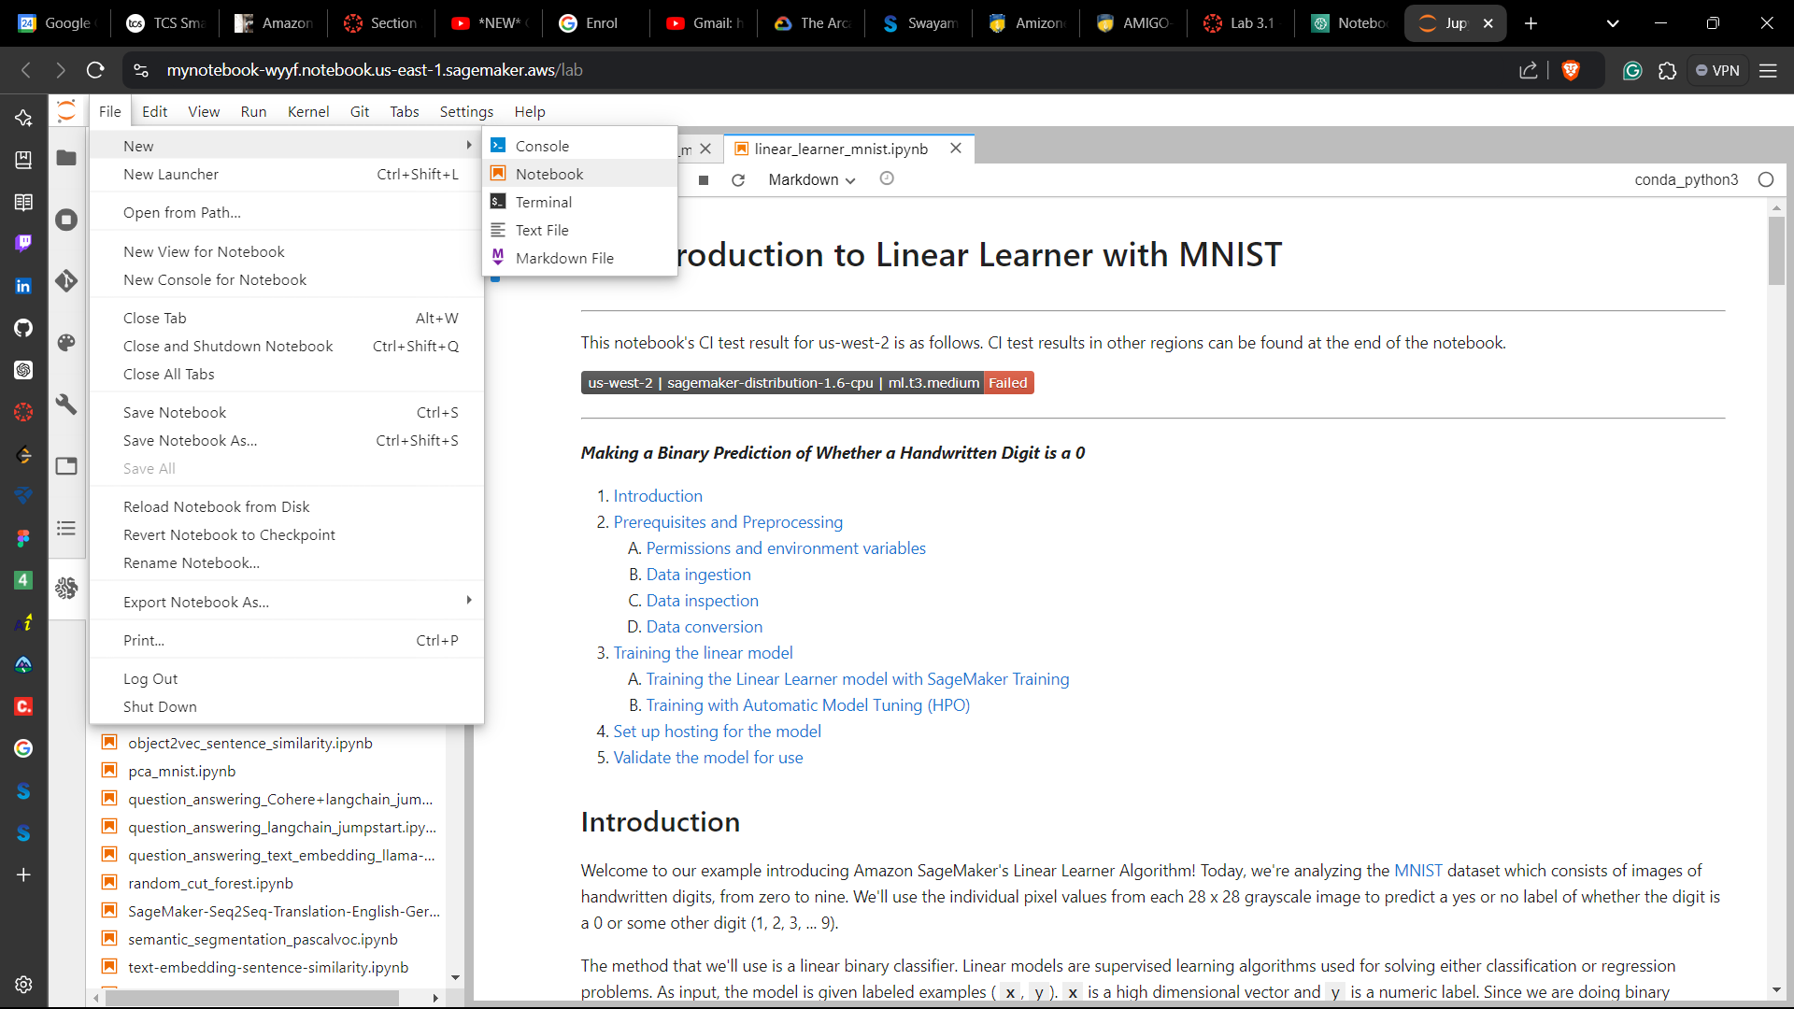

1. In the **Select kernel** dialog window, choose conda_python3 and then choose **Select**.

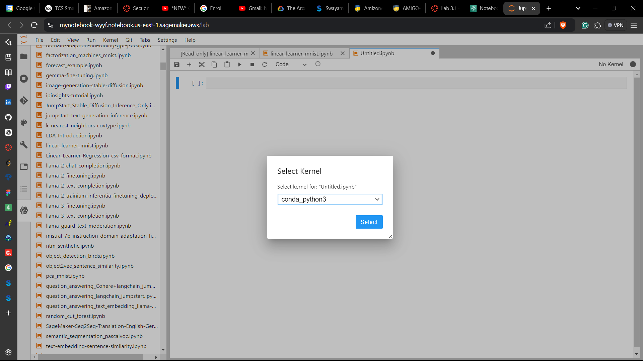

1. Press ENTER and in the cell, enter the following text:

# Importing the data

1. To exit the cell and render the Markup, press SHIFT + ENTER.
2. Press ENTER and then type the sample code from lab into the cell
3. Exit the cell without running the code by pressing ESC.

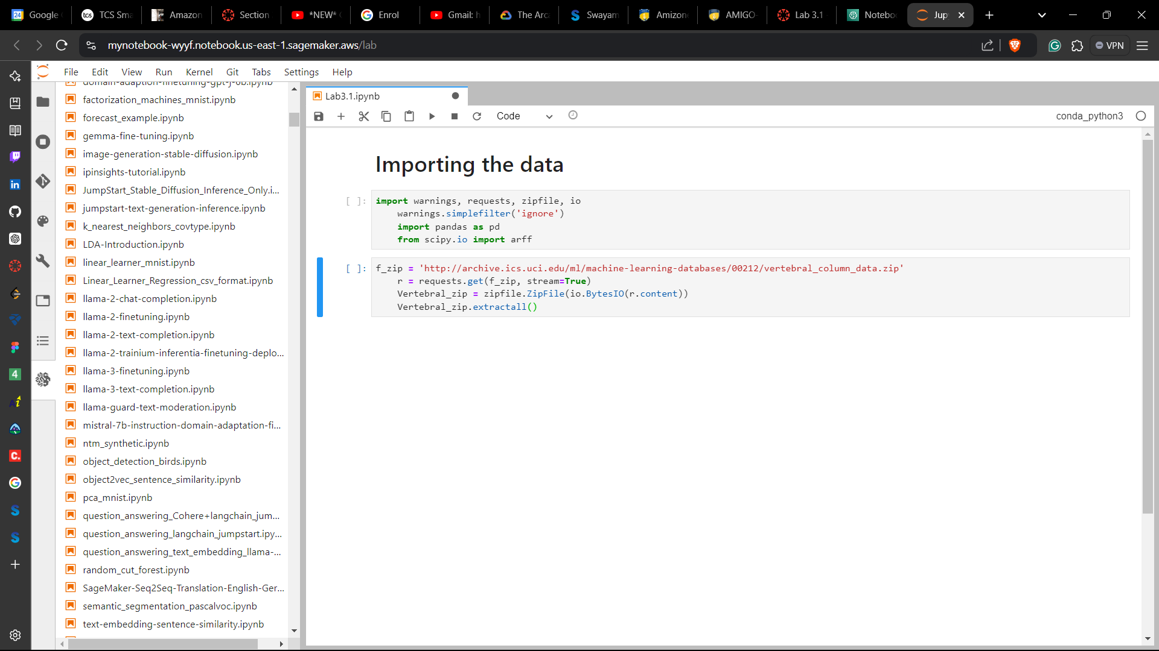

1. Run the code by pressing SHIFT + ENTER.

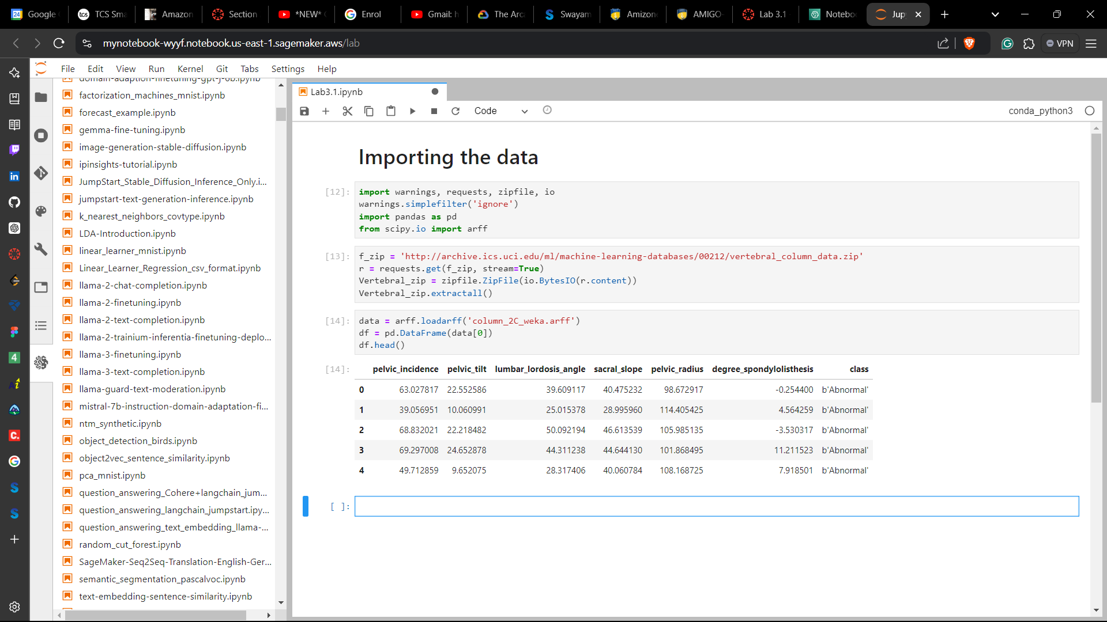

**Task 5: Downloading your notebook and saving your work**

1. In the file browser in the left navigation, right-click the file that you want to save, then choose **Download**.
2. Next, choose the location where you want to save your file on your local computer.

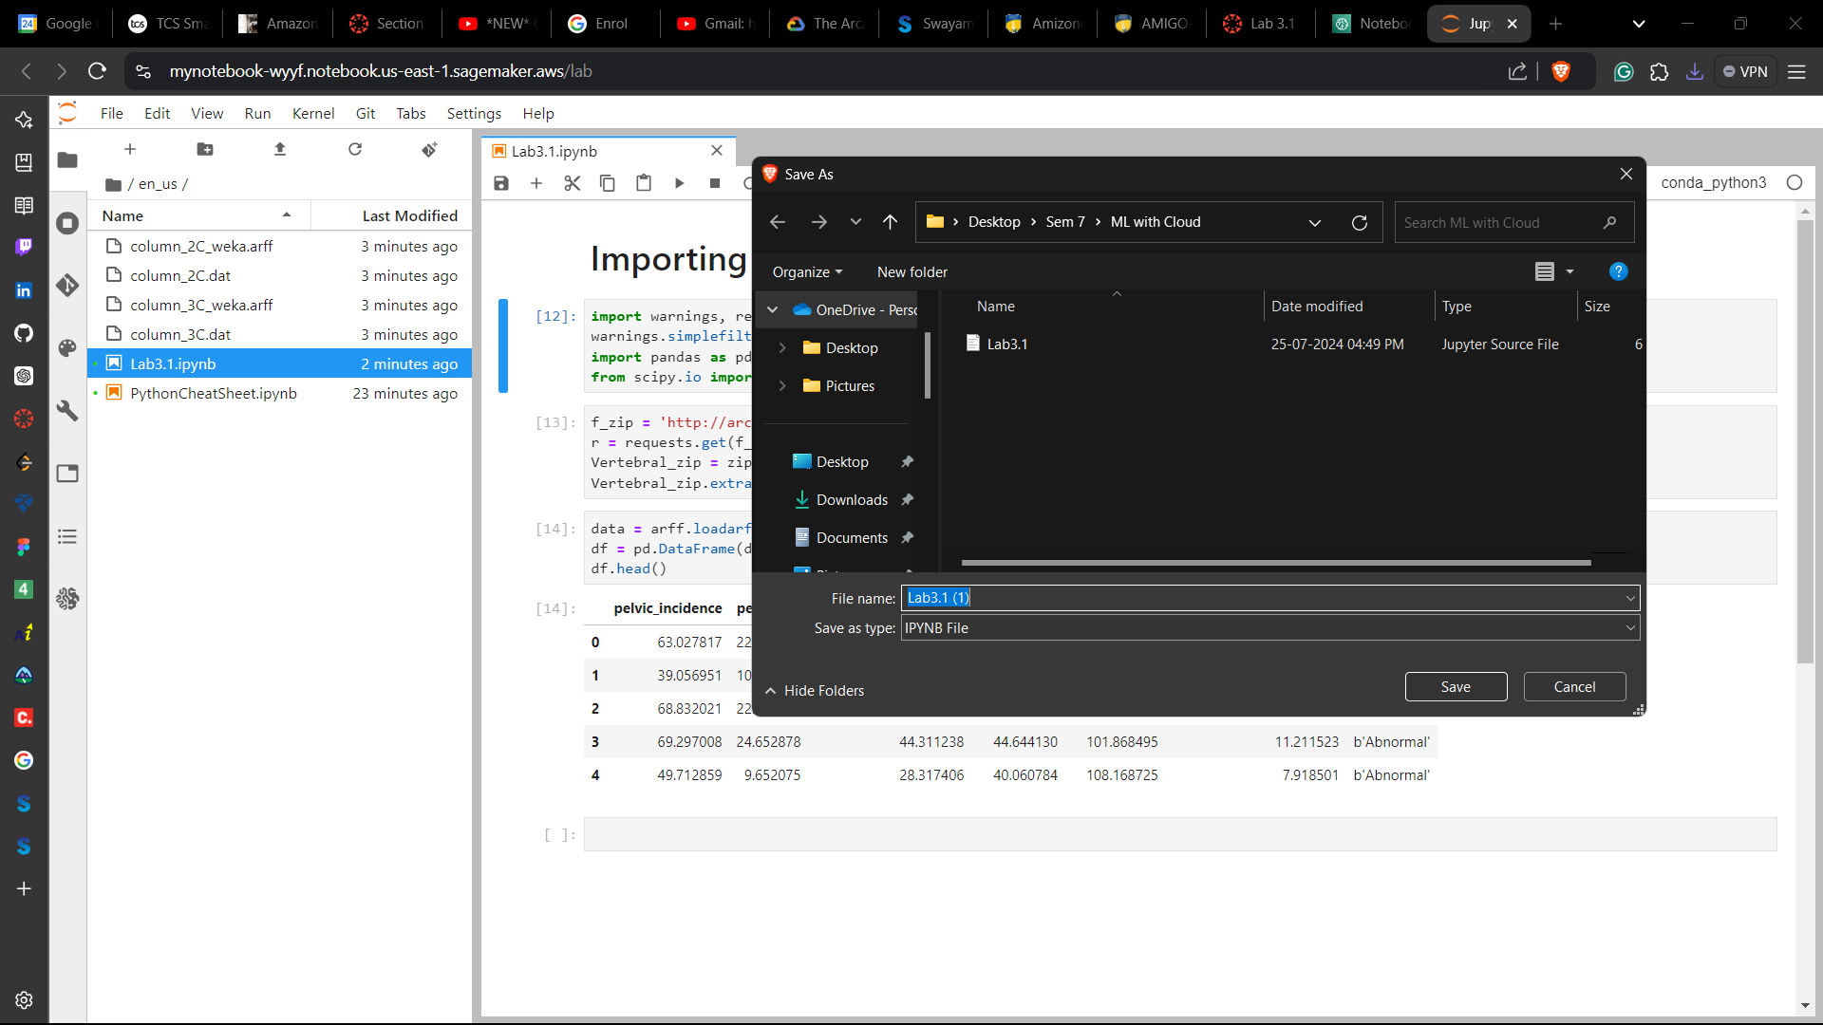

1. In order to end the lab, choose End Lab, and then choose **Yes**.

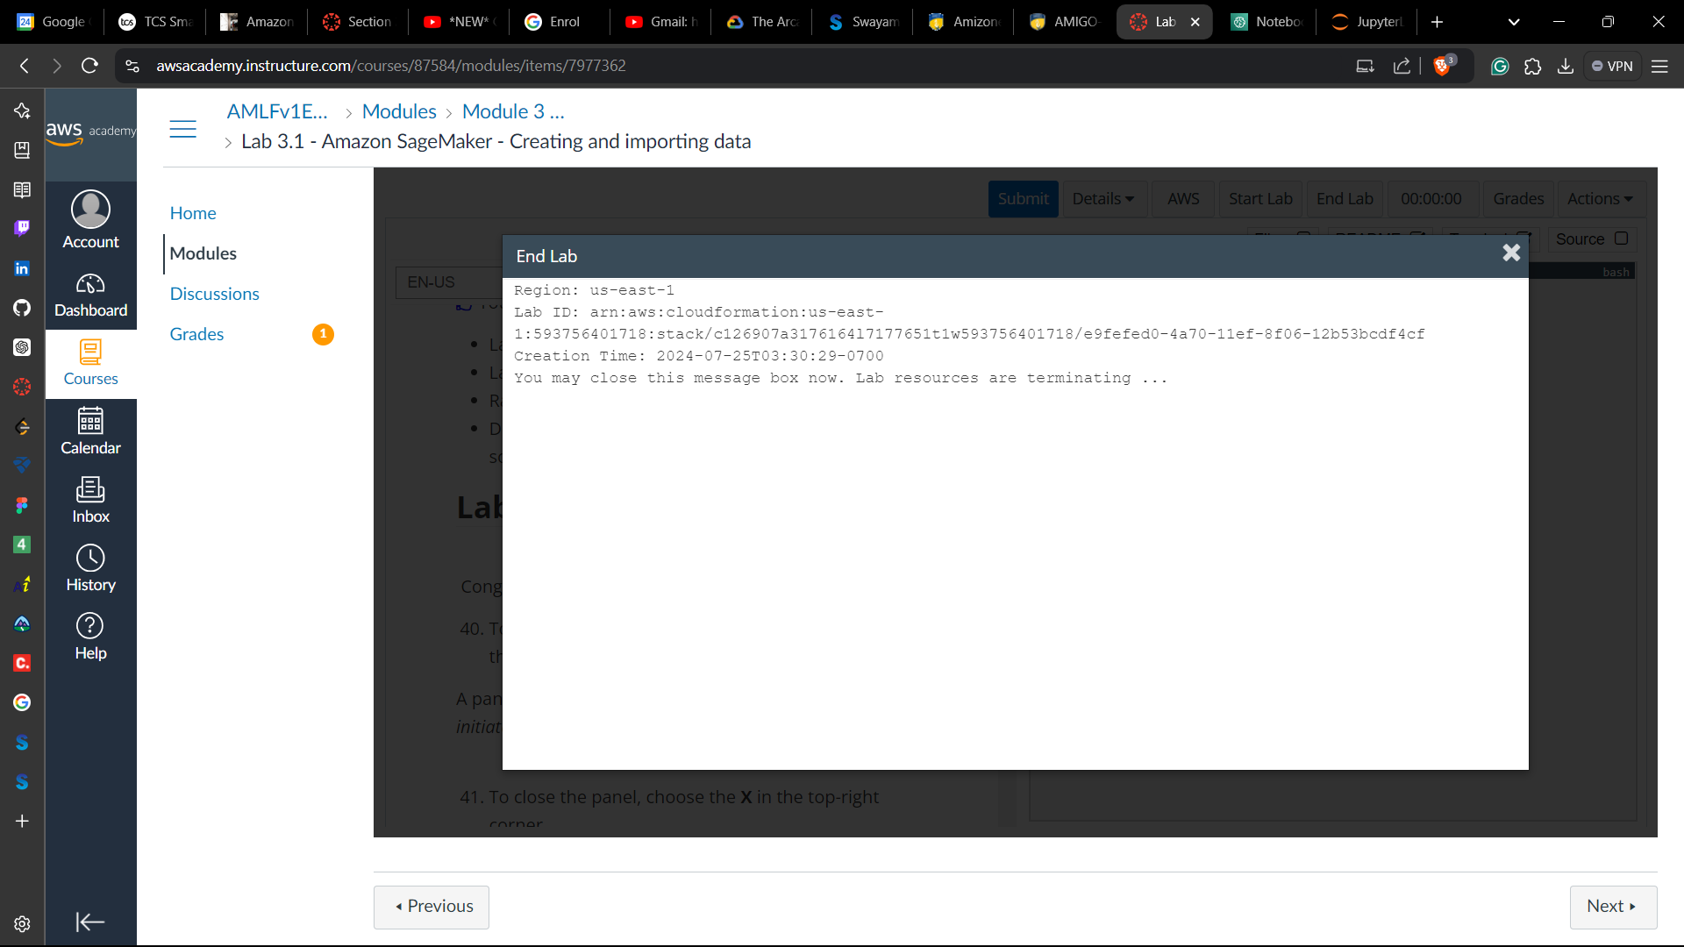

**LAB – 2**

Objective: Amazon SageMaker - Exploring Data

Procedure:

1. Accessing the AWS Management Console

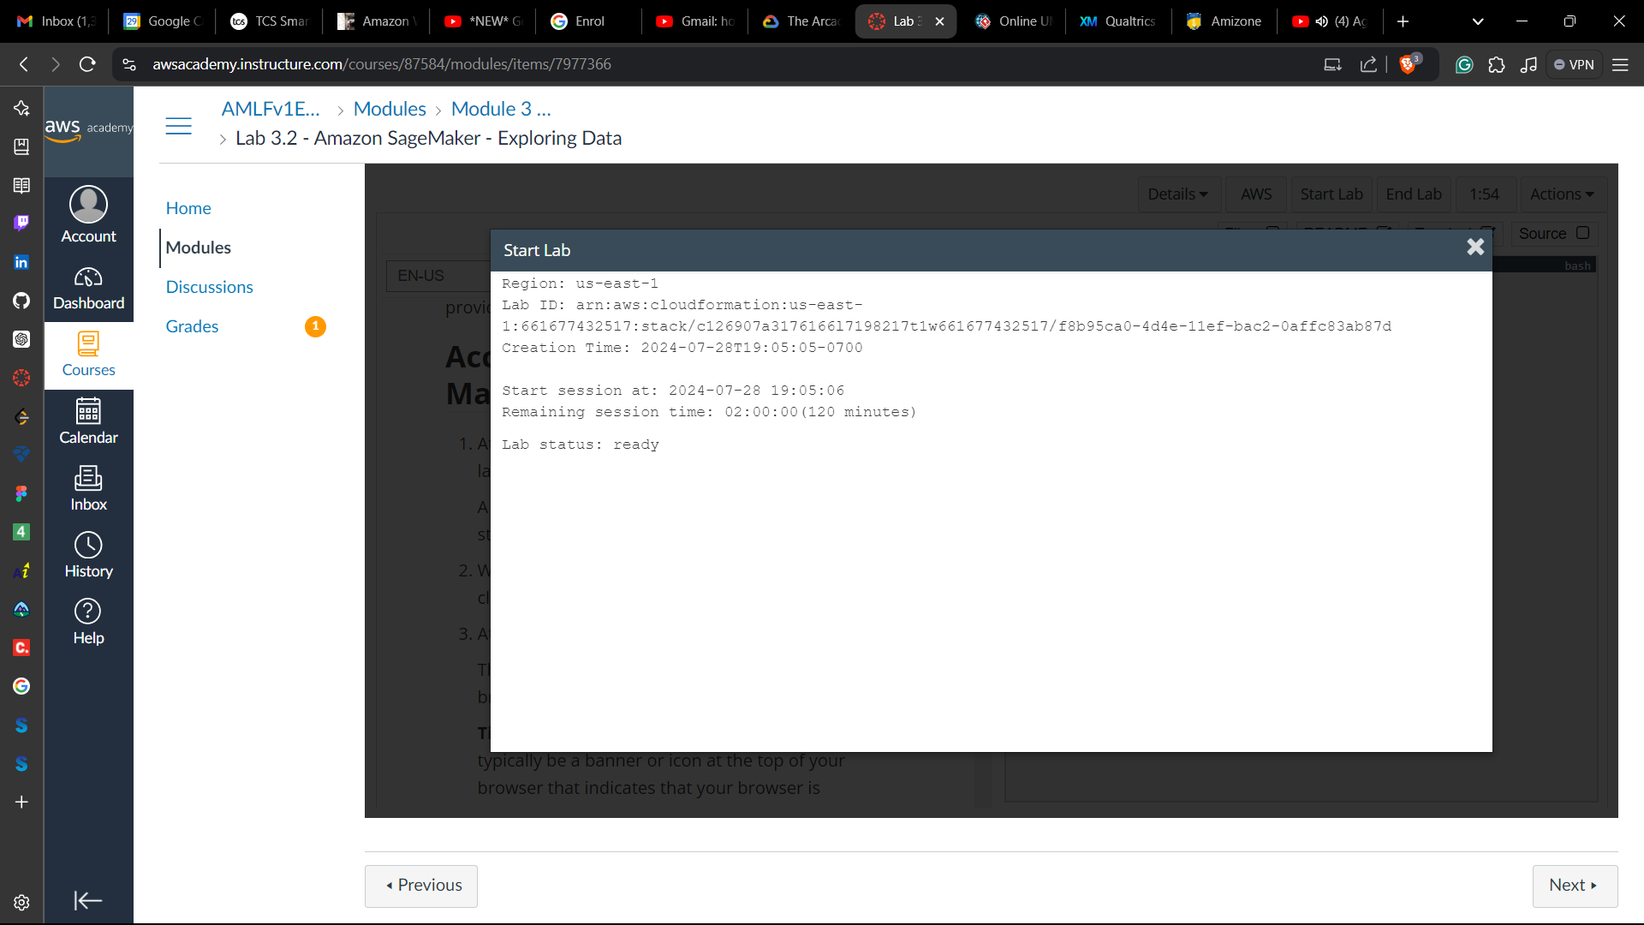

**Task 1: Accessing a notebook instance in Amazon SageMaker**

1. On the AWS Management Console, on the **Services** menu, choose **Amazon SageMaker**.
2. From the navigation menu on the left, expand the **Notebook** section and choose **Notebook instances**.
3. Look for the notebook instance named MyNotebook. Open the JupyterLab notebook instance by going to the end of the row and choosing **Open JupyterLab**.

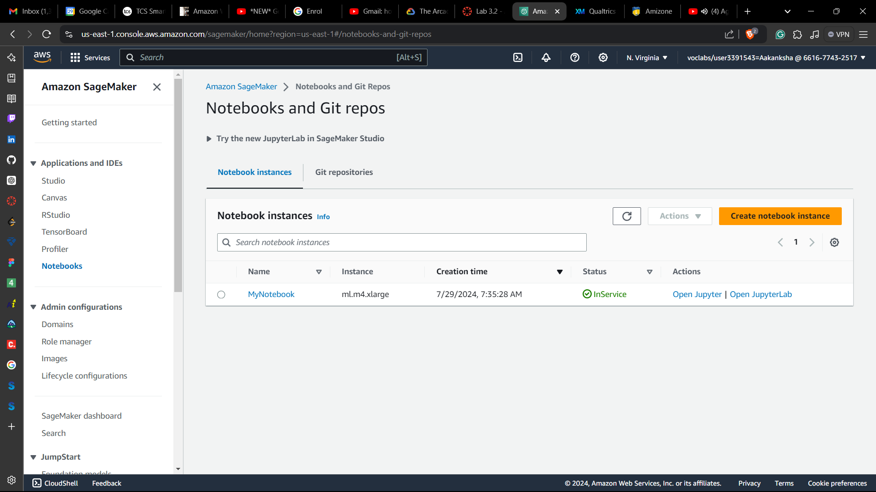

**Task 2: Opening a notebook in your notebook instance**

1. In your JupyterLab environment, go to the file browser in the left pane and locate the 3_2-machinelearning.jpynb file & open it.

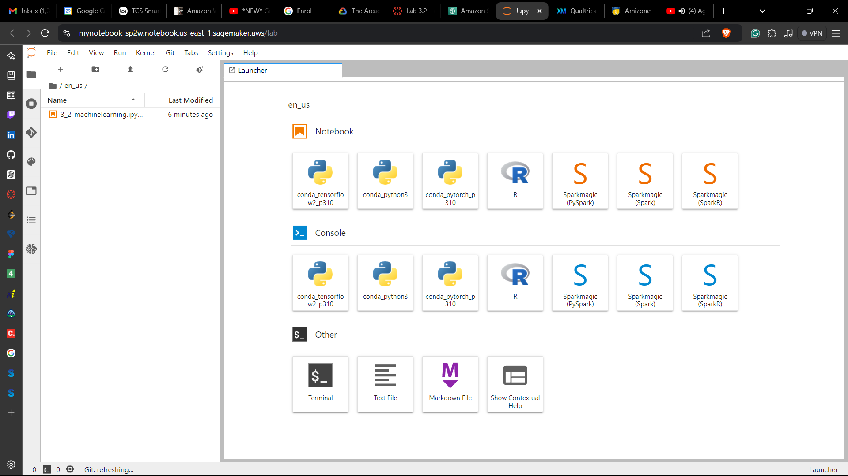

1. Follow the instructions in the notebook explore the data

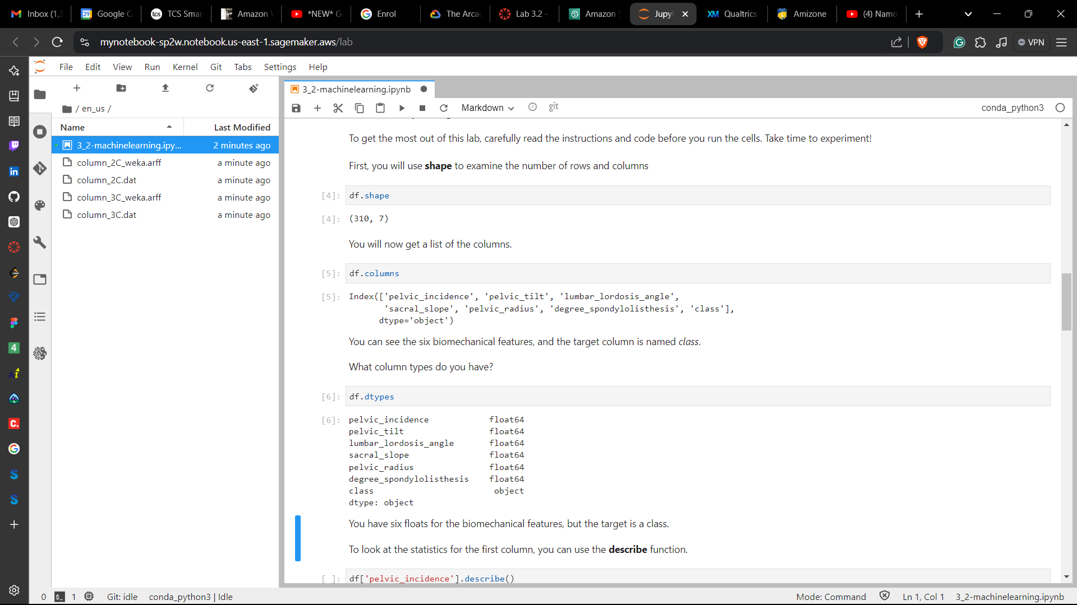

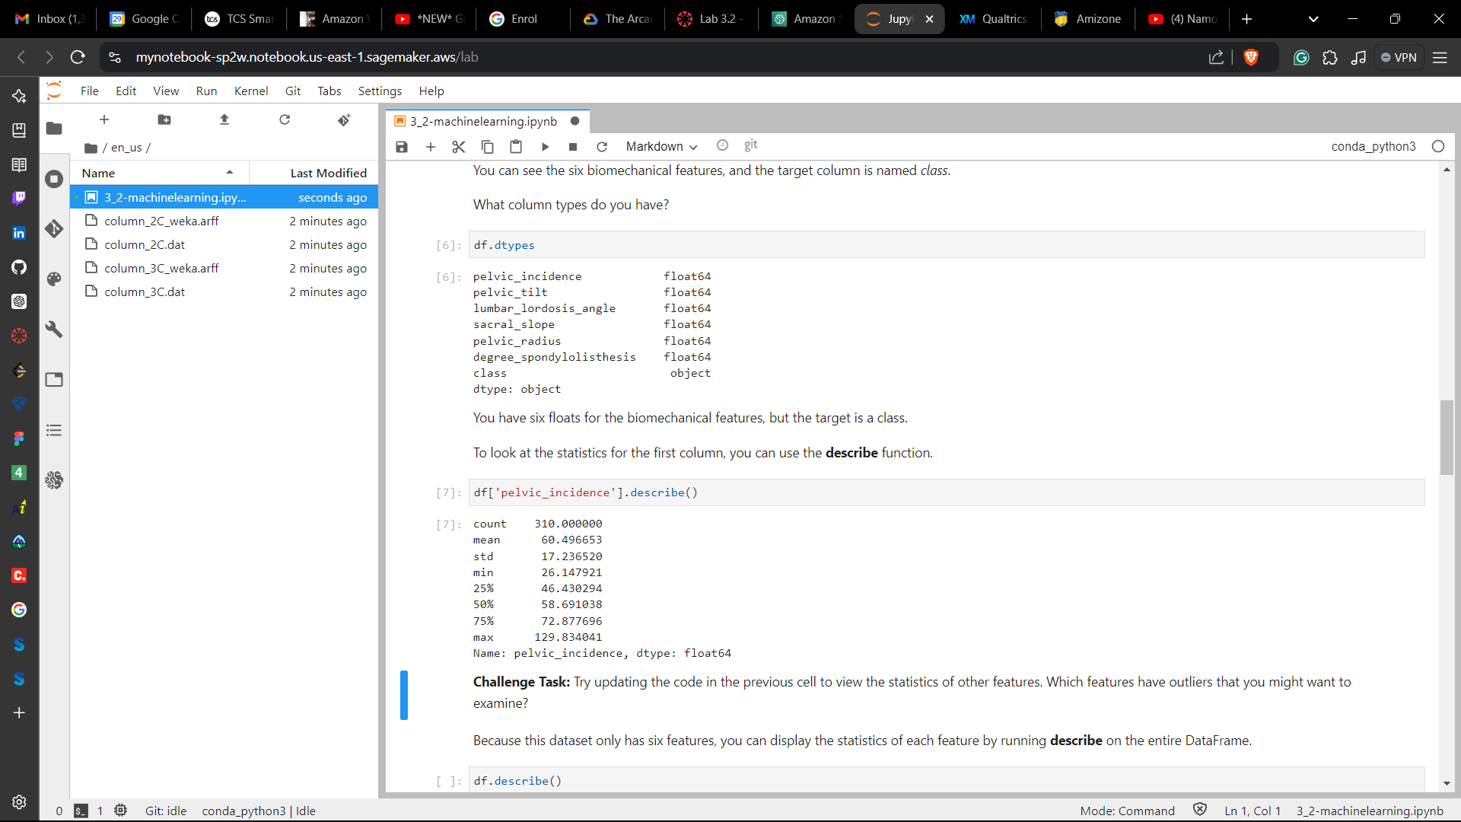

**Challenge Task #1:** Try updating the code in the previous cell to view the statistics of other features. Which features have outliers that you might want to examine?

* Examining ‘sacral_slope’

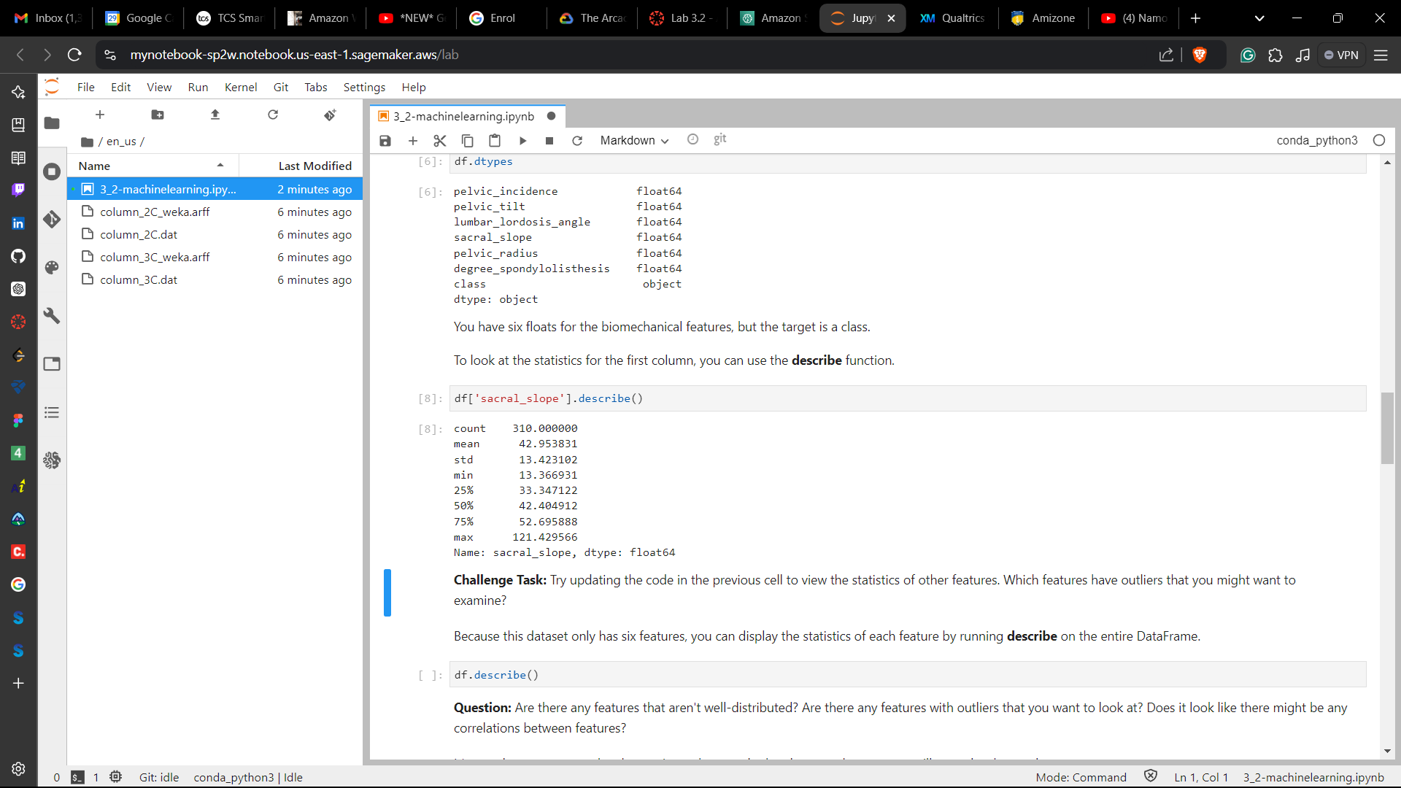

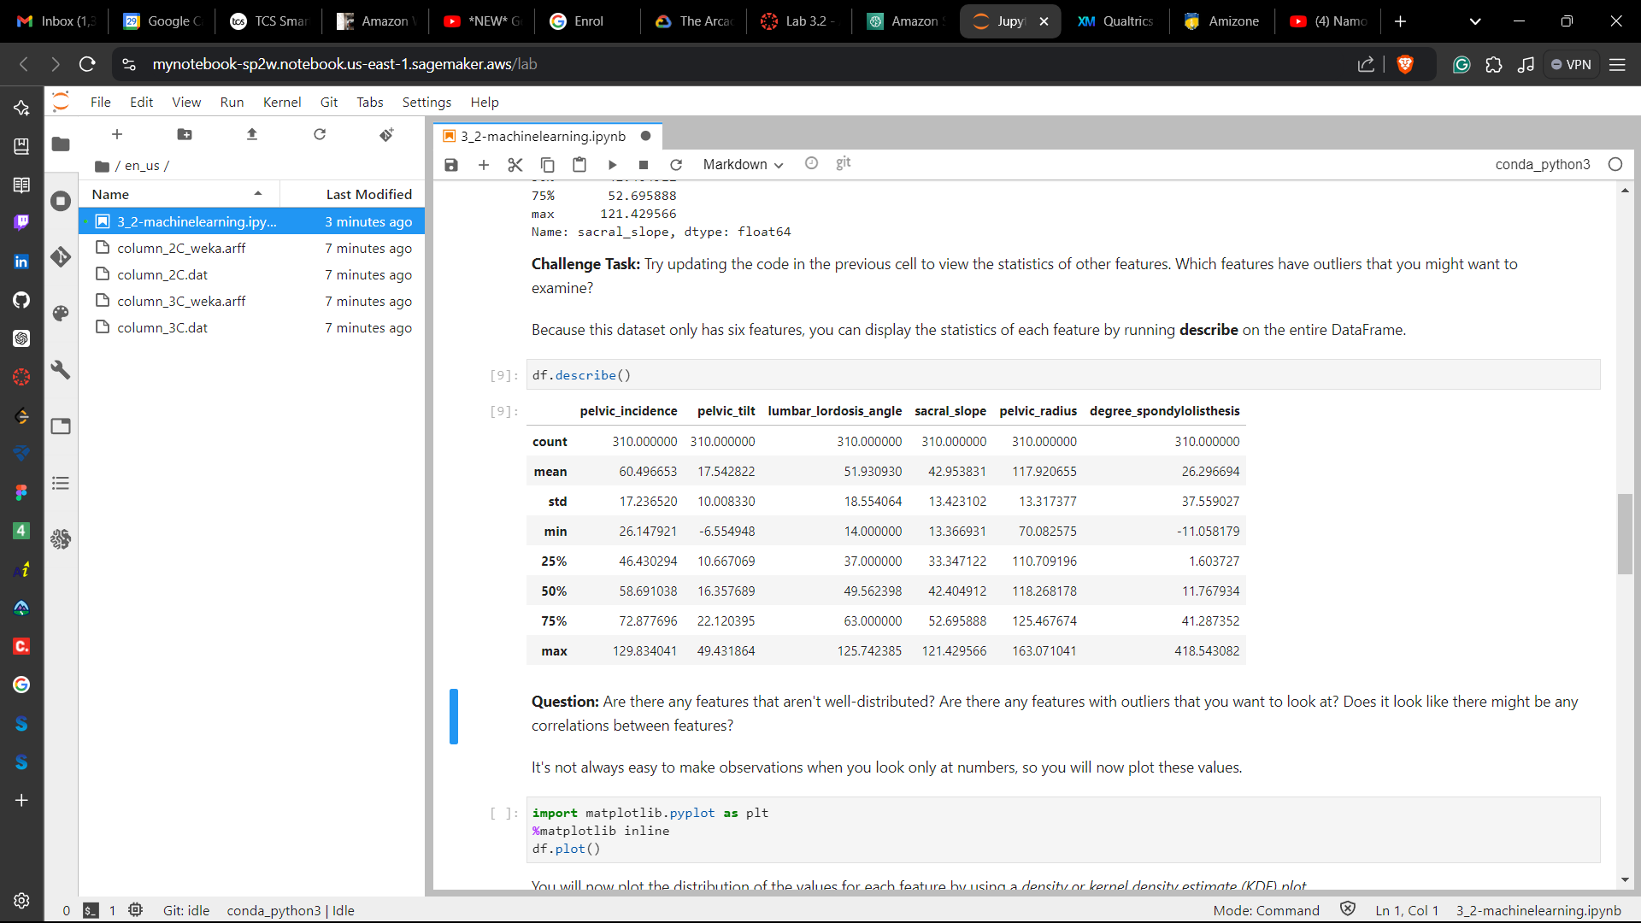

Plotting the different features:

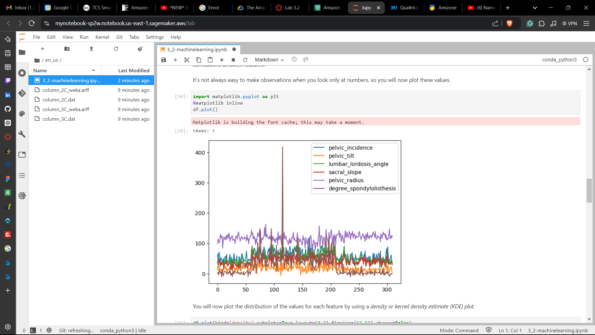

Plotting the distribution of the values for each feature by using a *density or kernel density estimate (KDE) plot:*

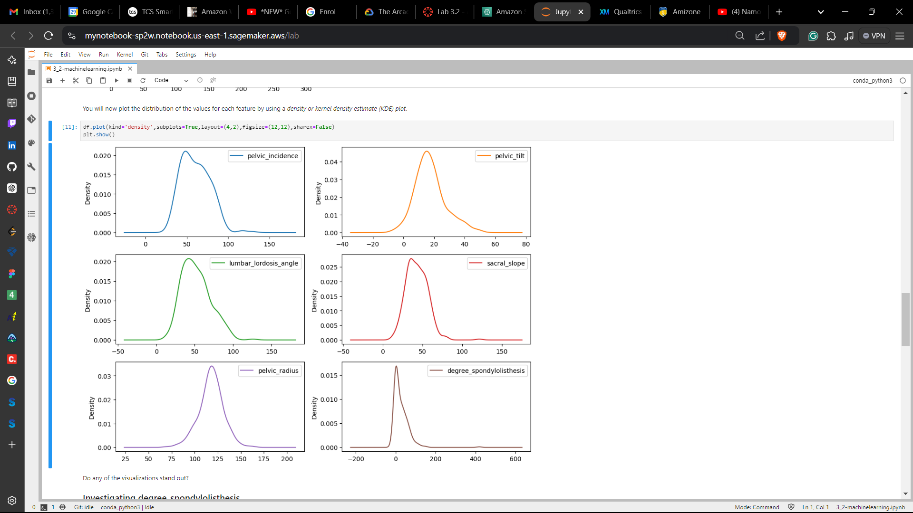

**Investigating degree_spondylolisthesis:**

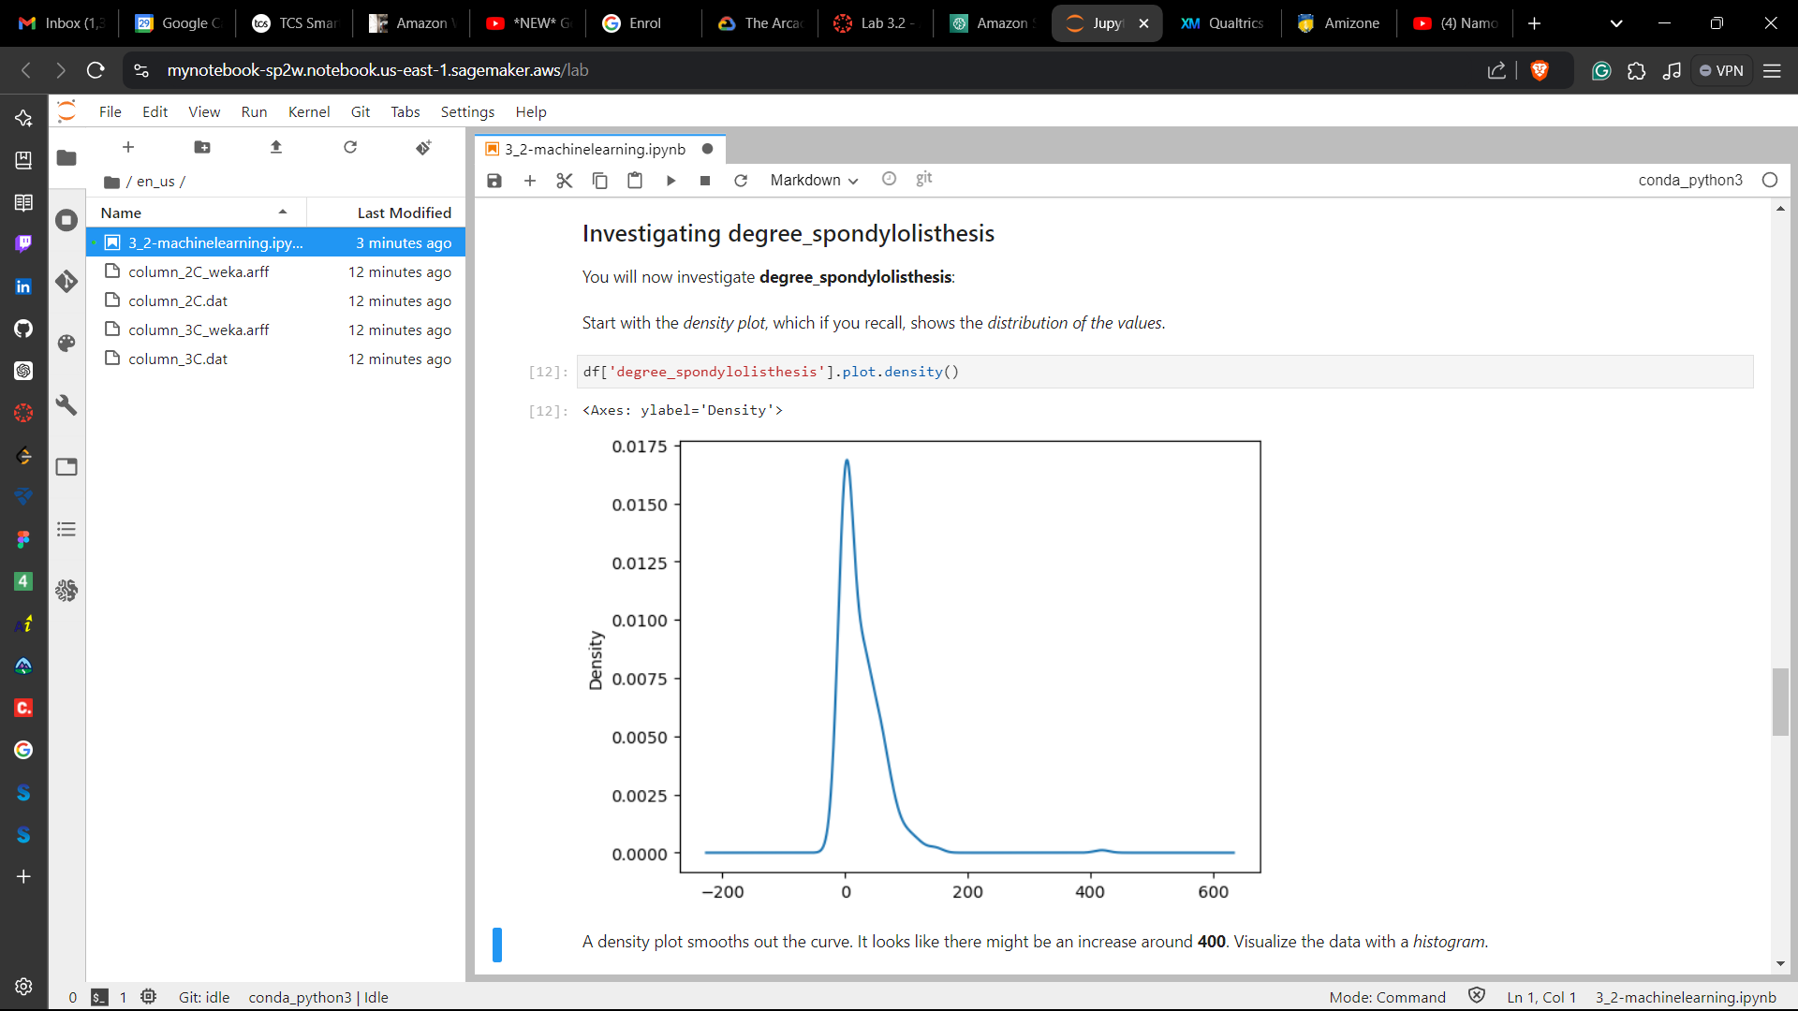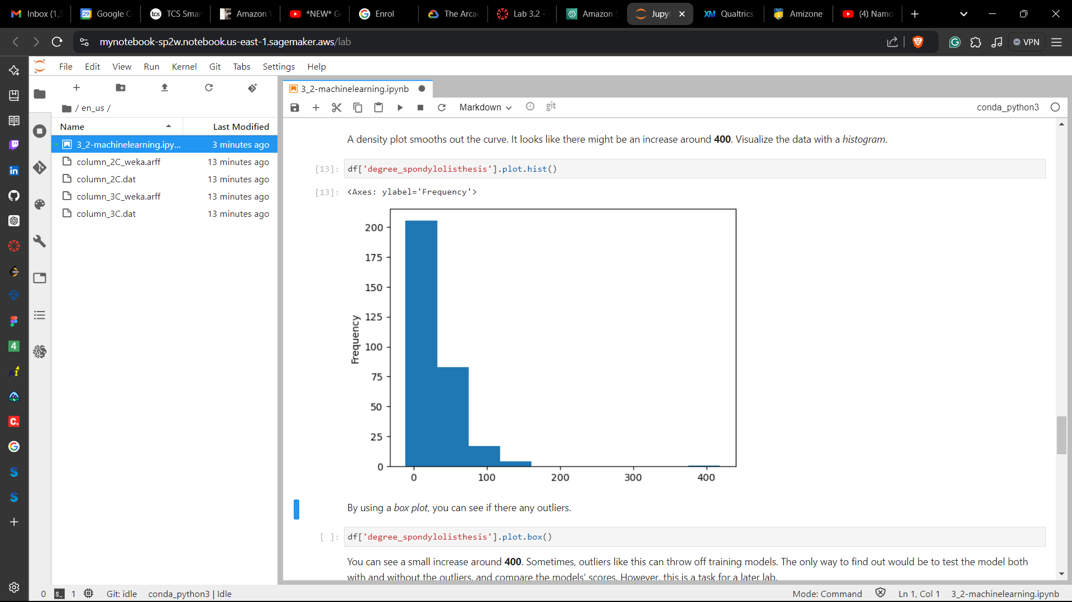

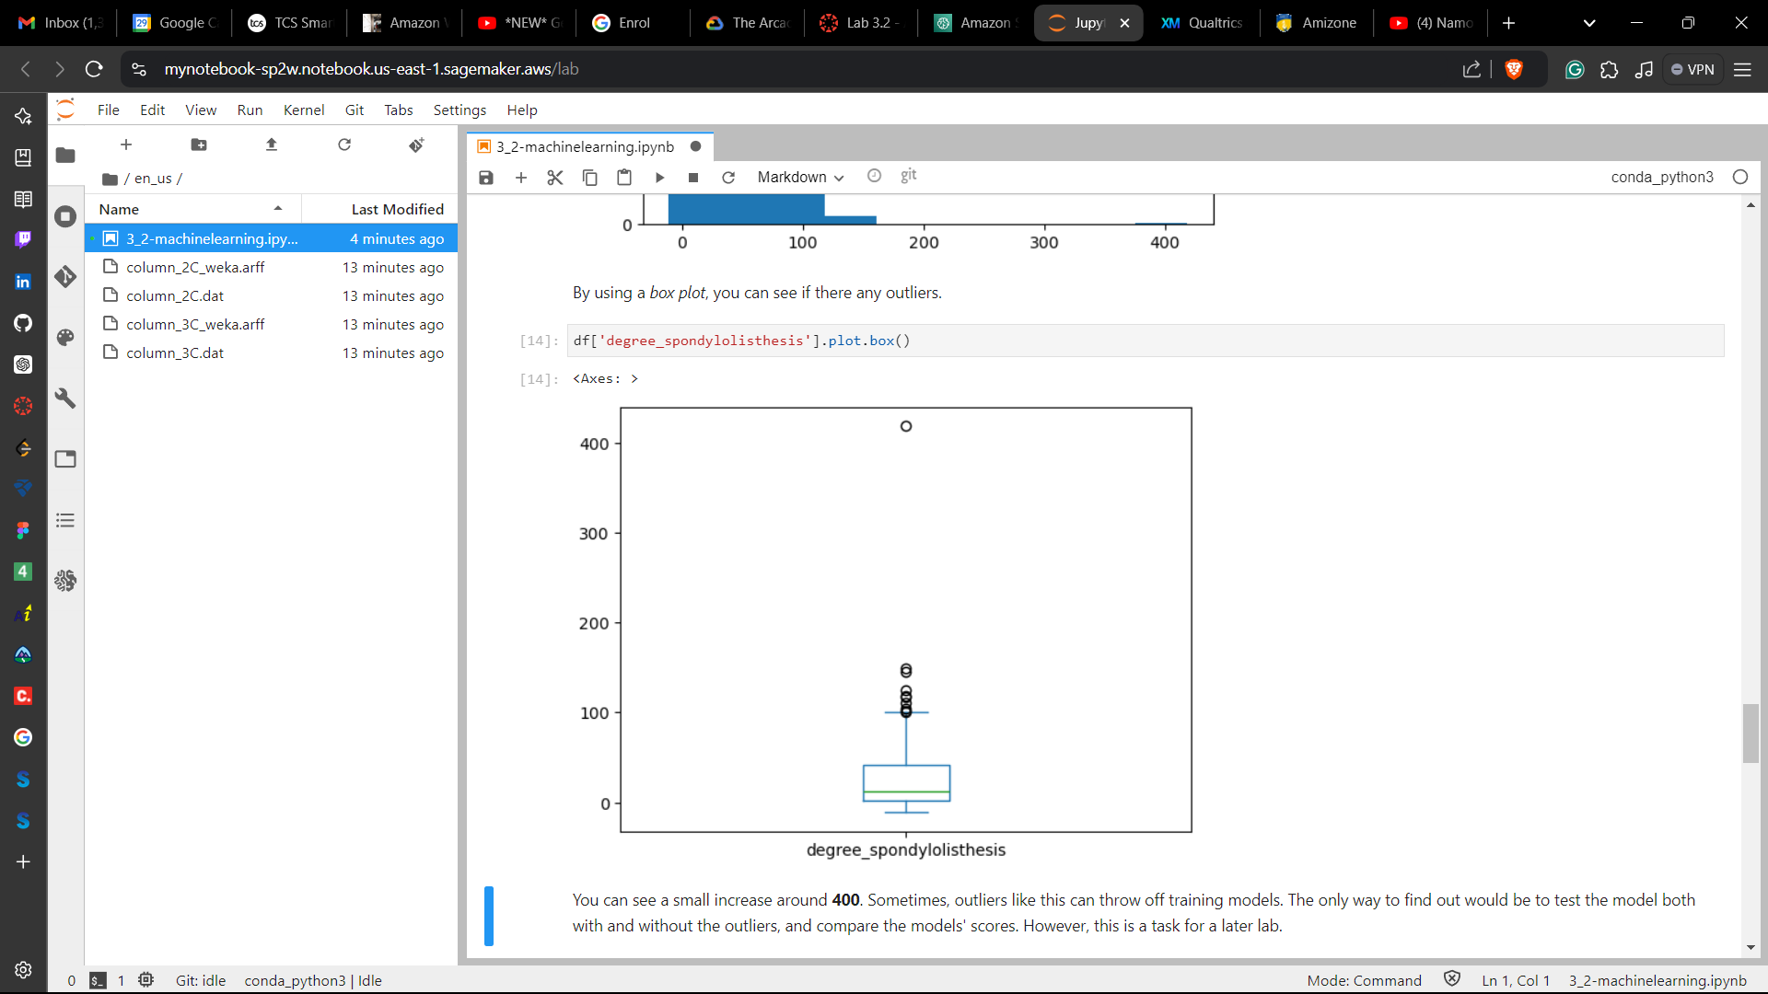

**Analyzing the target:**

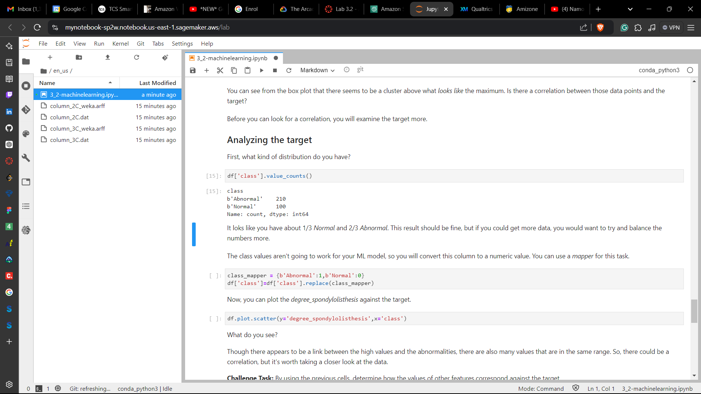

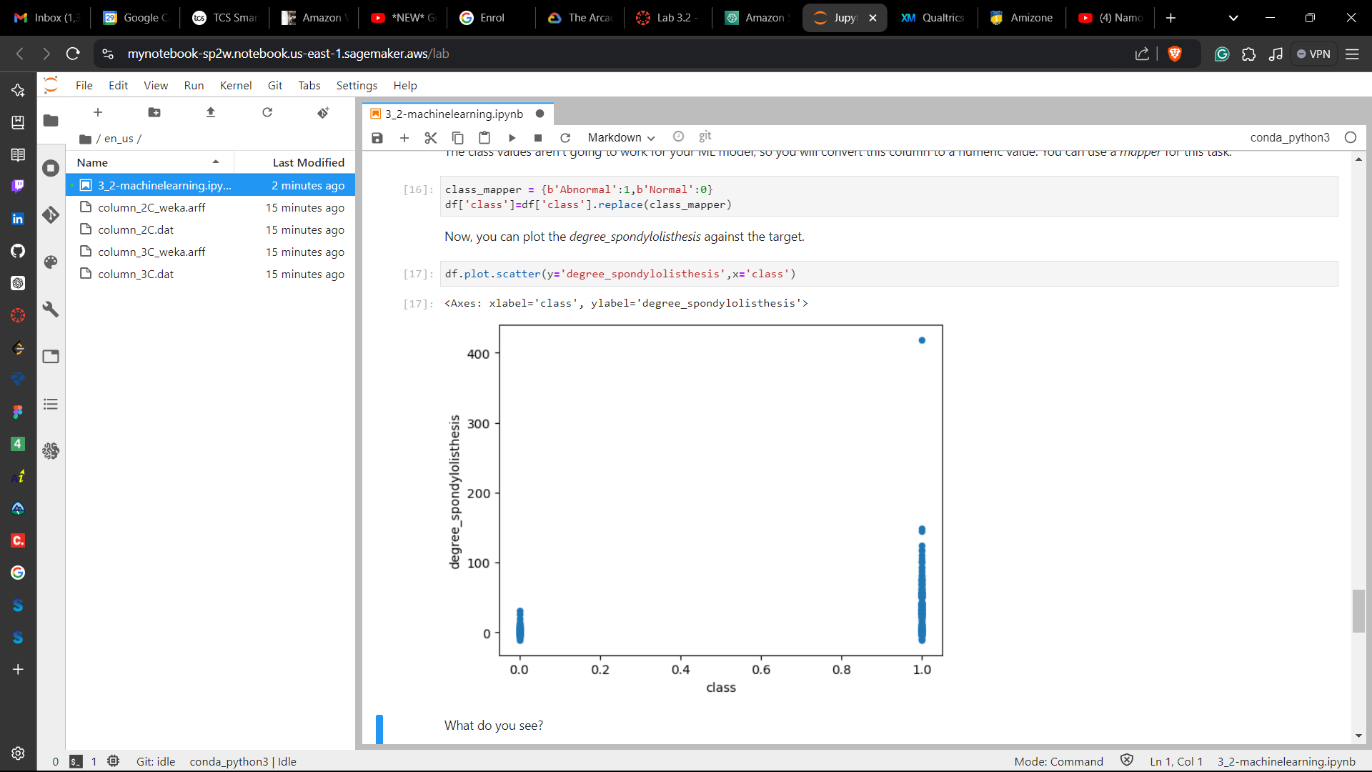

**Challenge Task #2:**By using the previous cells, determine how the values of other features correspond against the target.

* Examining ‘sacral_slope’ as the other feature

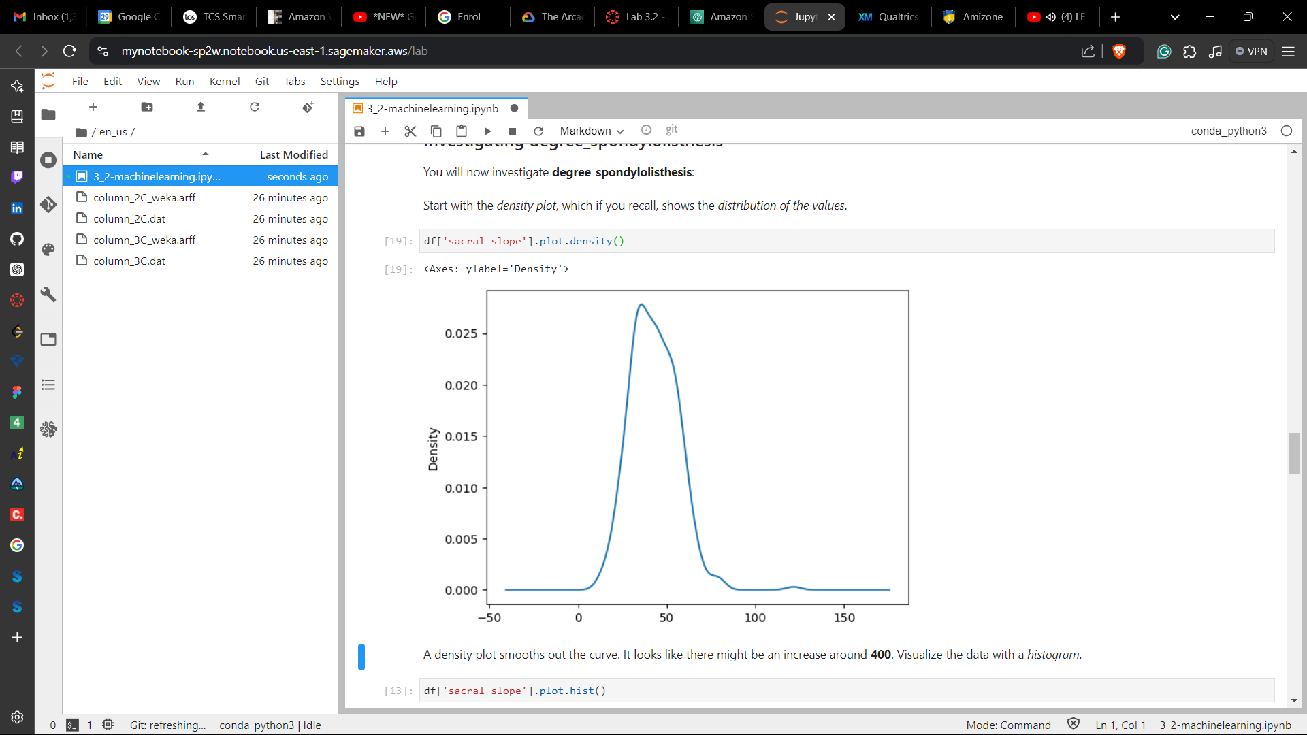 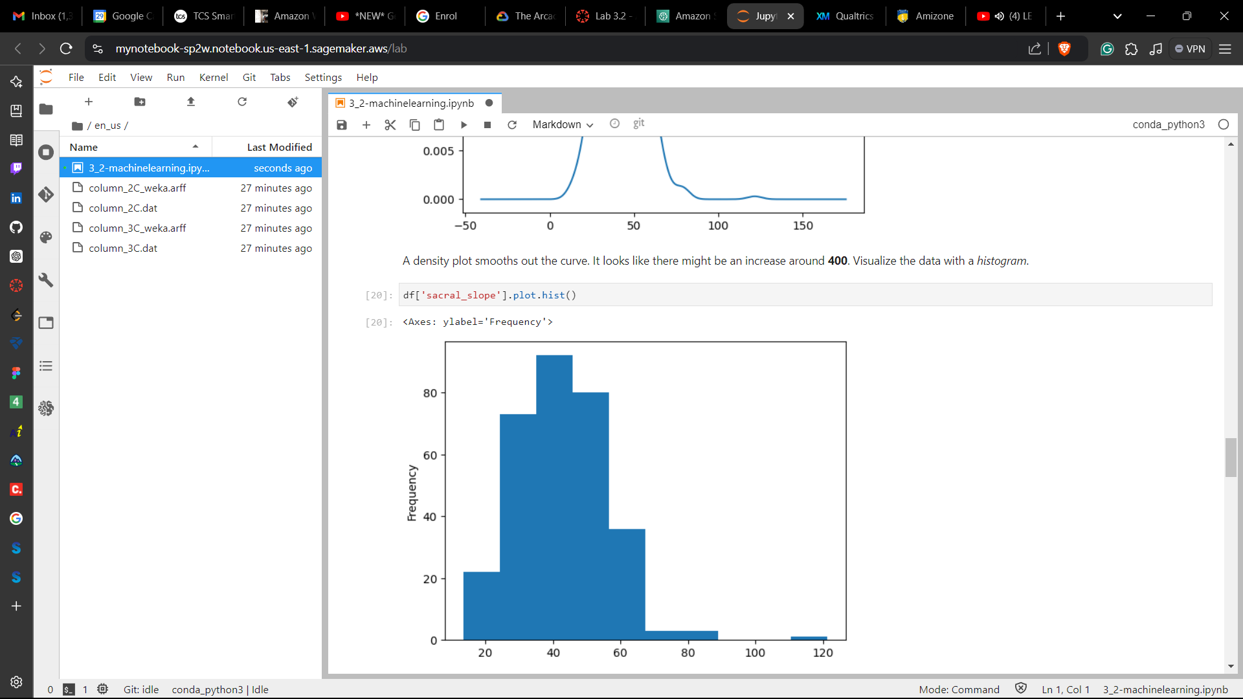

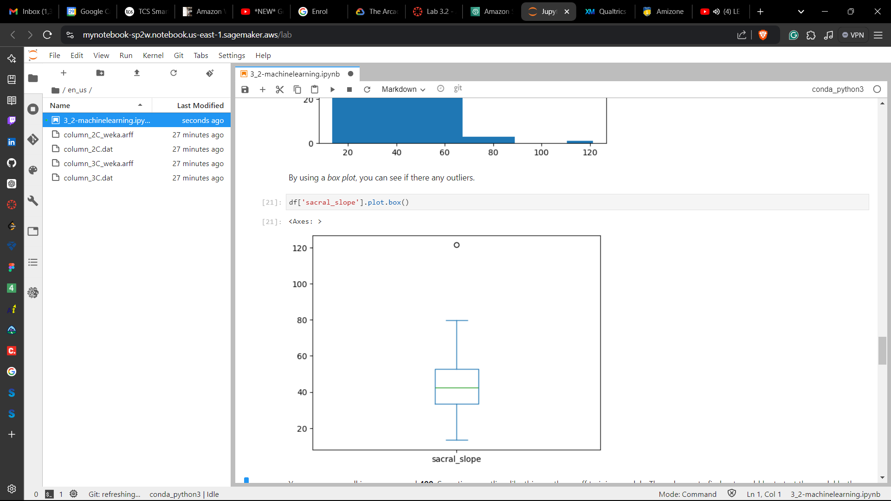 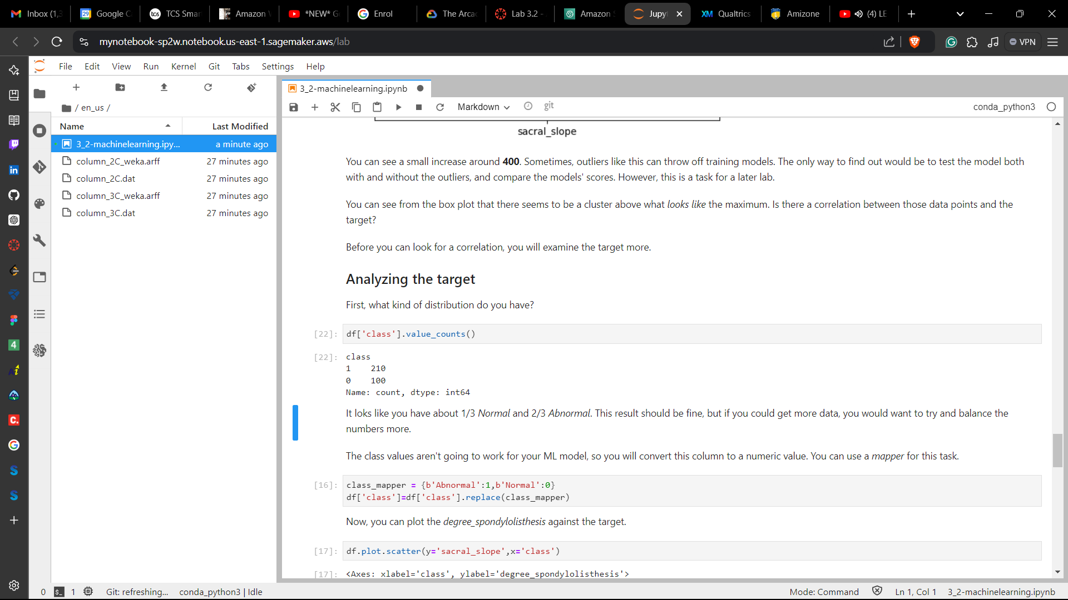

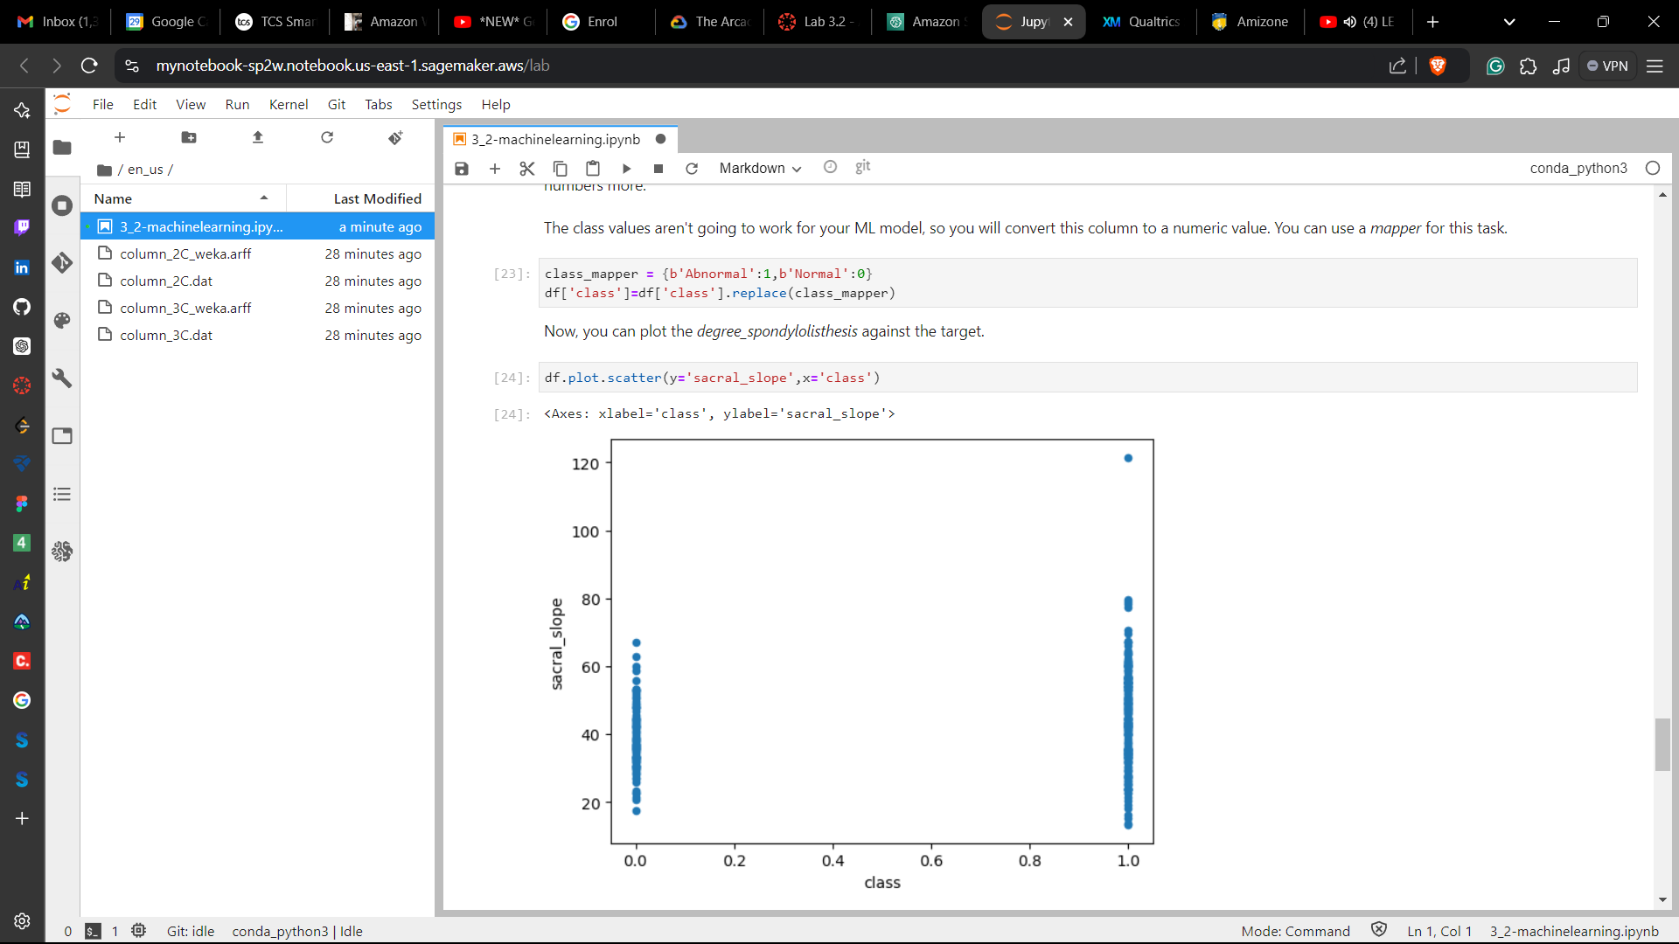

**Visualizing multiple variables:**

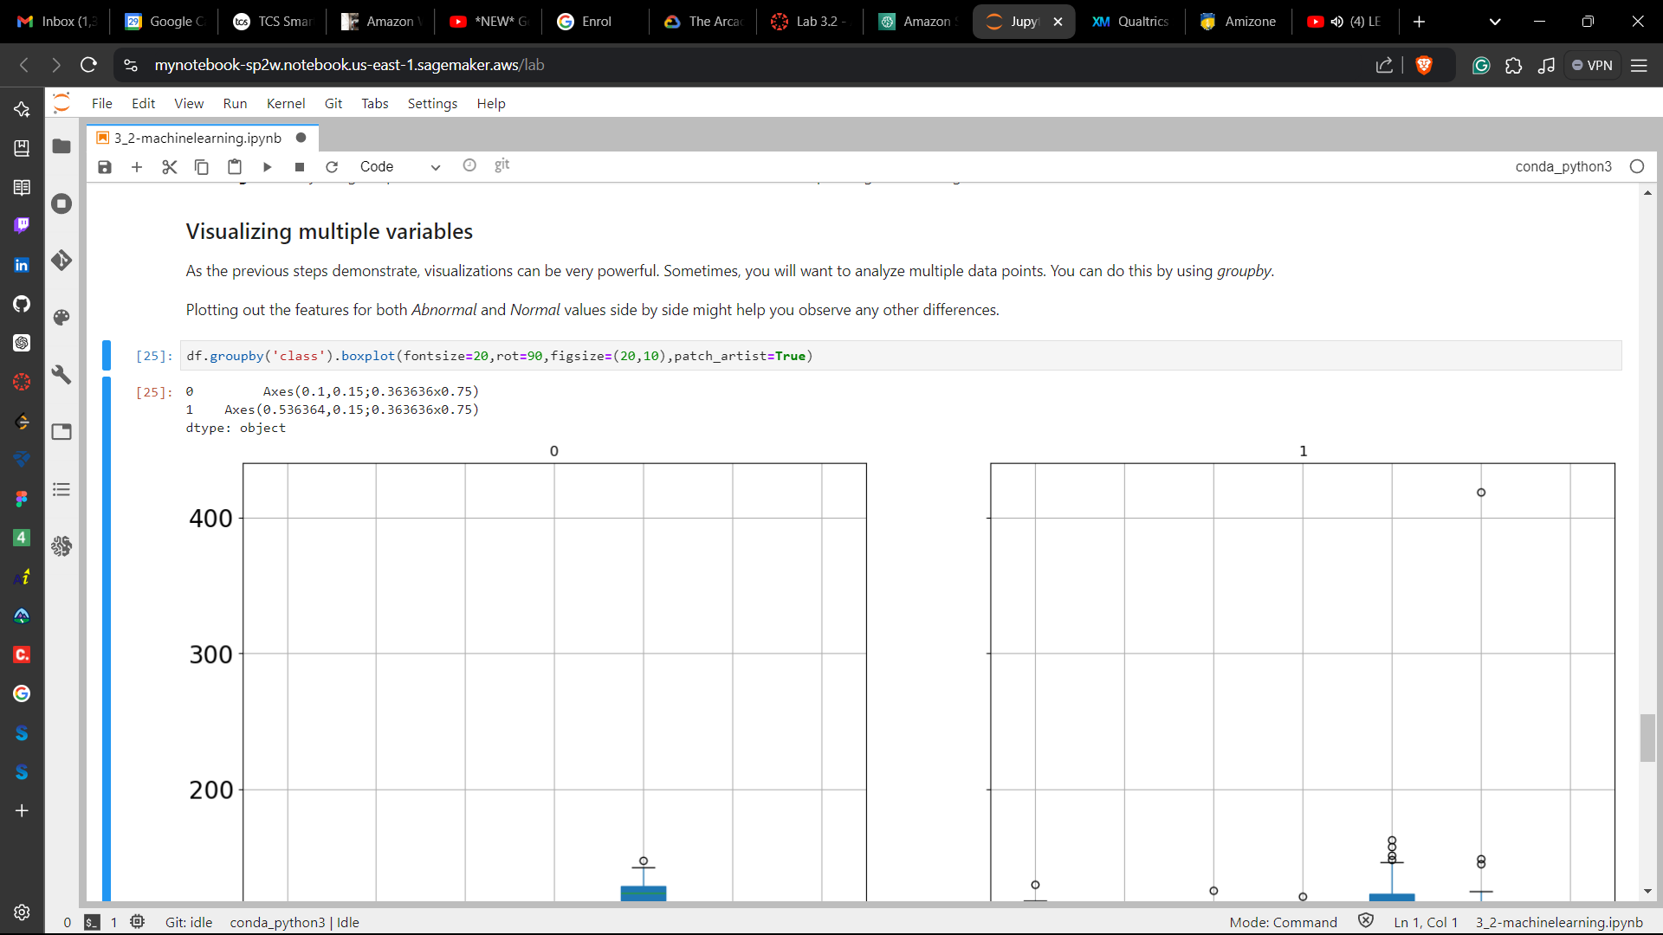

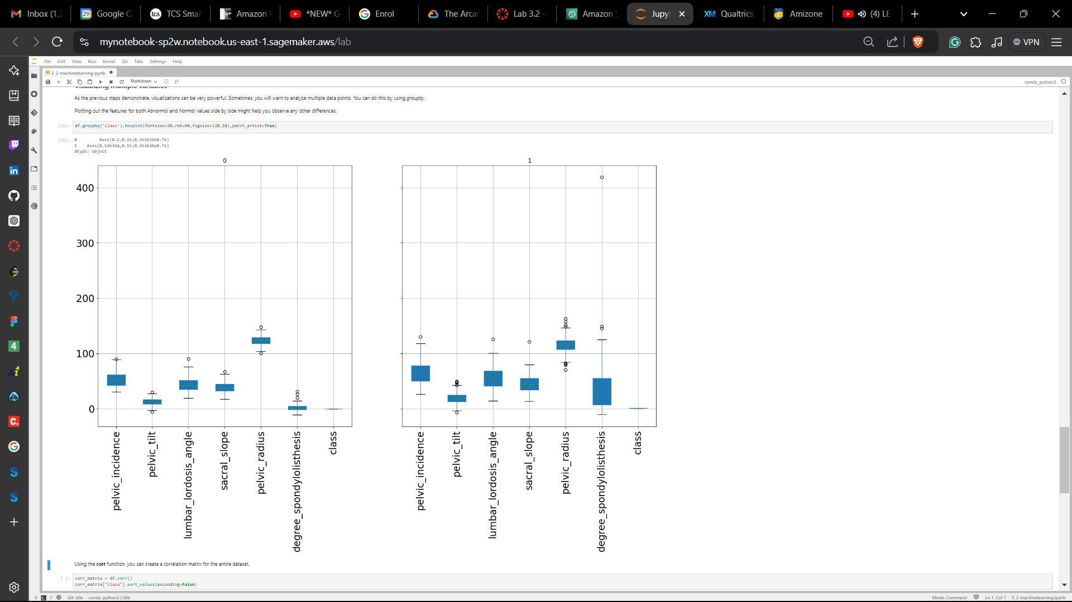

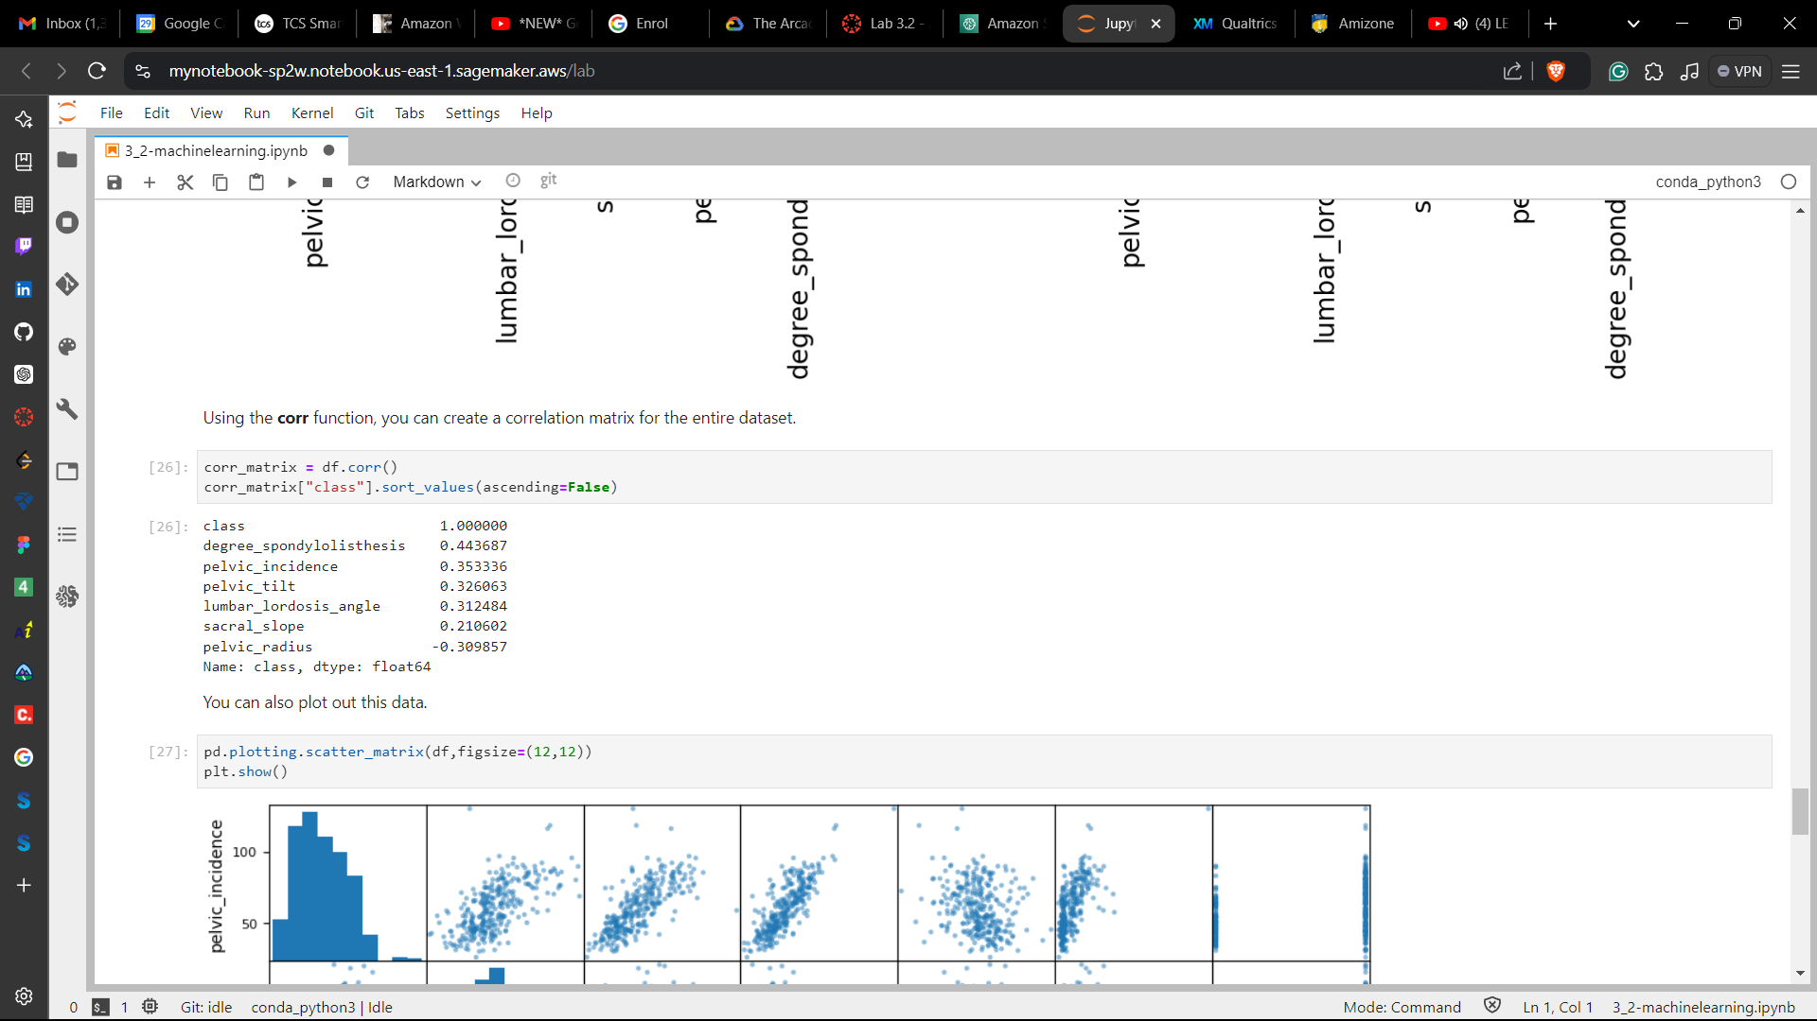

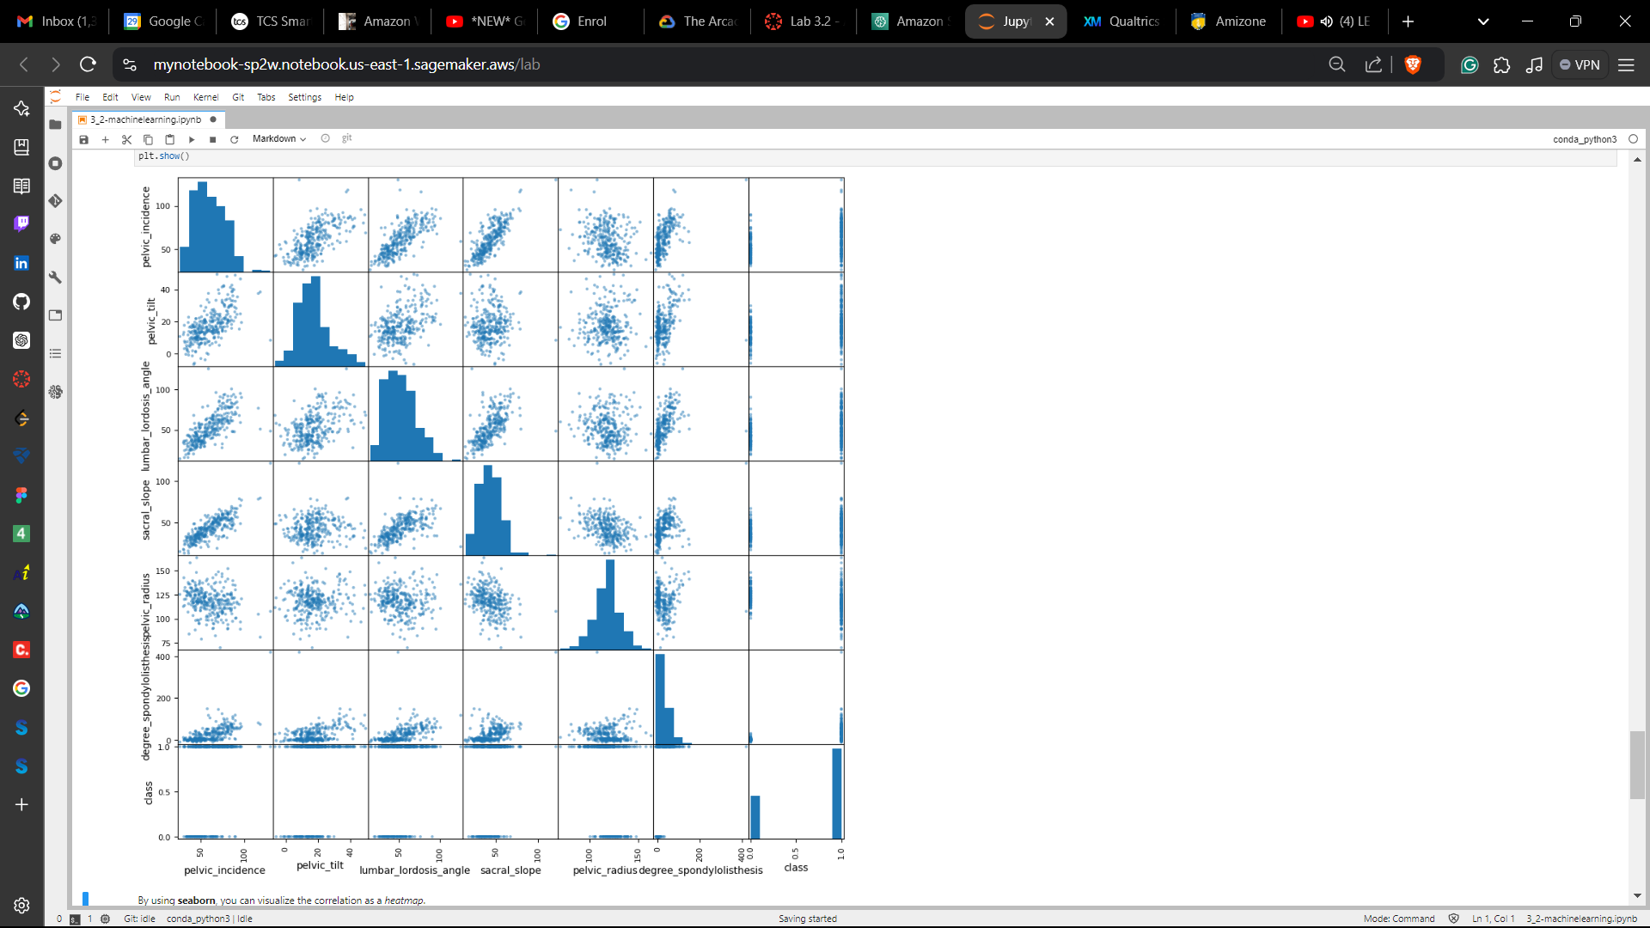

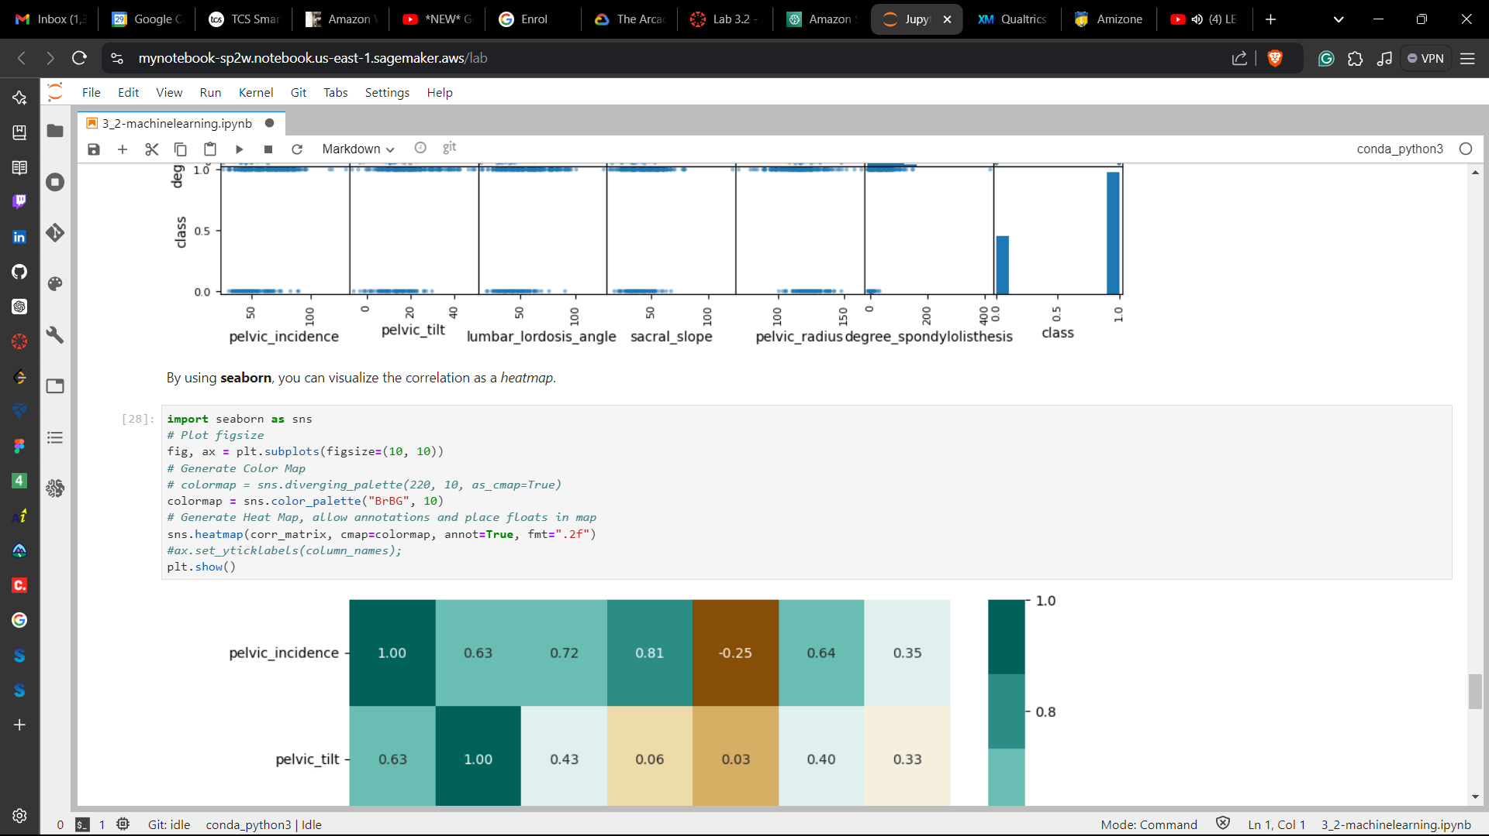

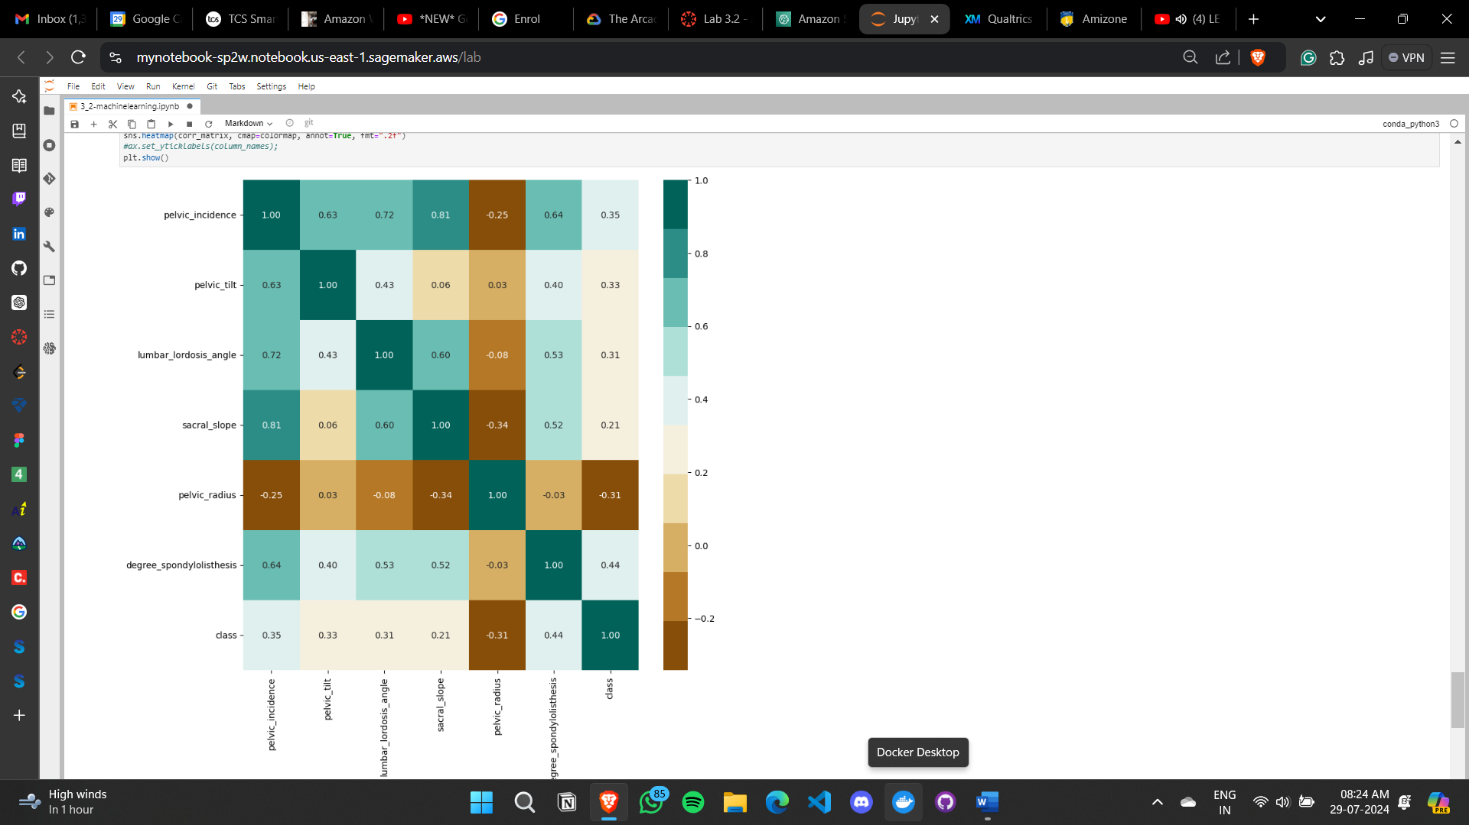

**Conclusion:**

* Examined the structure of a dataset by using pandas
* Viewed statistics with pandas and Matplotlib
* Looked for correlation between features in a dataset

**Lab complete**

1. In order to end the lab, choose End Lab, and then choose **Yes**.

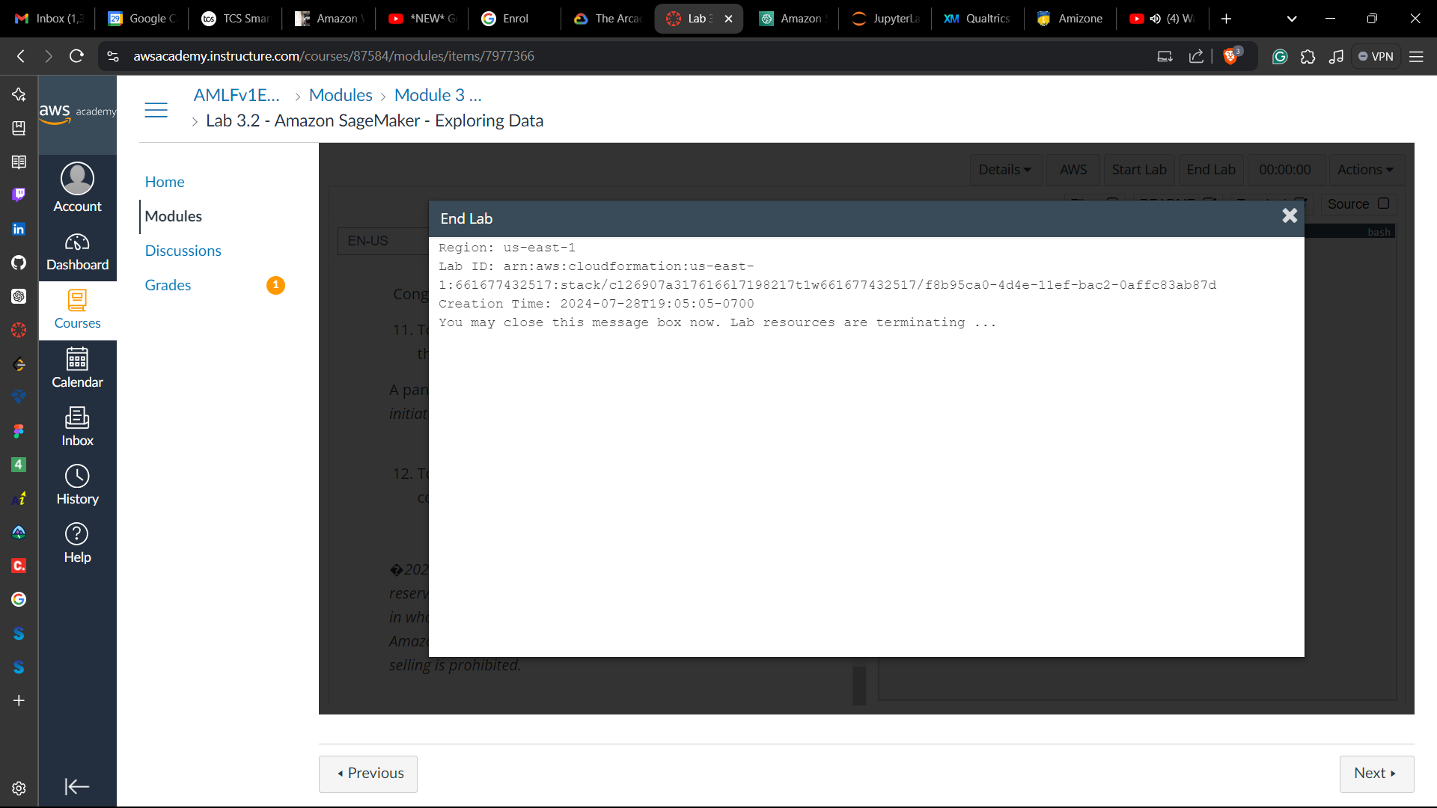

|  |  |  |  |
| --- | --- | --- | --- |
| **S.NO.** | **LAB OBJECTIVE** | **DATE OF PERFORMANCE** | **SIGN OF FACULTY** |
|  |  |  |  |
|  |  |  |  |
|  |  |  |  |
|  |  |  |  |
|  |  |  |  |
|  |  |  |  |
|  |  |  |  |
|  |  |  |  |
|  |  |  |  |
|  |  |  |  |